# **Data Engineering with AWS Part 1**

### [**https://github.com/LinkedInLearning/data-engineering-AWS-1-3010976**](https://github.com/LinkedInLearning/data-engineering-AWS-1-3010976)

### 

### **Data engineering with AWS**

Selecting transcript lines in this section will navigate to timestamp in the video

- [Instructor] We live in a world where amount of data being utilized is constantly increasing. As a result, more and more companies talk about being data driven in there decision making. But for an organization to be truly data driven, they need expertise about managing and drawing insights from these complex data sources. In this course, I'll help you to start your AWS data engineering journey with easy to follow, hands on exercises. I'll go from the foundational concepts, all the way to building data engineering pipelines using AWS services. I'm Dipali Kulshrestha, and I have been programming professionally for 18 years. I'm currently managing data engineering projects. In Part 1 of this course, I'll primarily cover data sourcing, ingestion and storage stages of data engineering pipeline. While in Part 2, I'll focus on data catalog, processing, analytics and visualization. Join me in my LinkedIn Learning course to fast track your career as a data engineering professional.

### **Overview of data engineering**

Selecting transcript lines in this section will navigate to timestamp in the video

- [Instructor] The key to understanding what data engineering lies in the engineering part. Engineers design and build things. Data engineers design and build pipelines that transform and transport data into a format, wherein by the time it reaches to data scientists or other end users, it is in a highly usable estate. These pipelines must take data from many disparate sources and collect them into a single warehouse that represents the data uniformly as a single source of truth. Sounds simple enough, but a lot of data literacy skills goes into this role. Let's look at the data science hierarchy of needs. It depicts where data engineering falls in the roadmap to becoming a data science, or AI driven organization. It's worth noting, that the bottom level collect is growing larger and larger, thereby driving the need for more data engineers. A data engineer's role is at level two and three. Data engineers work in a variety of settings to build systems that collect, manage, and convert raw data into a usable information for data scientist and business analyst to interpret. Their ultimate goal is to make data accessible, so that organizations can use it to evaluate and optimize their performance. The term data engineering evolved to describe a role that moved away from using traditional ETL tools and developed its own tools to handle increasing volumes of data. As big data grew, data engineering came to describe a kind of software engineering, which includes intelligence of business, with logical analytics, that focused deeply on data. For example, data infrastructure, data warehousing, data mining, data modeling, data crunching, and meta data management.

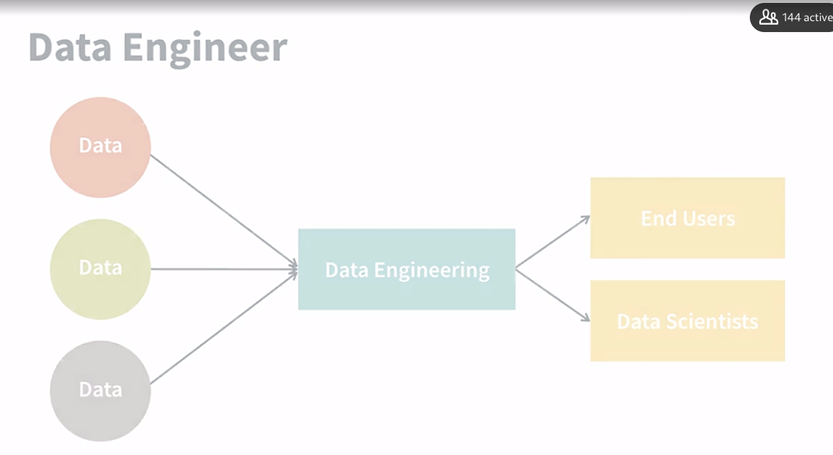

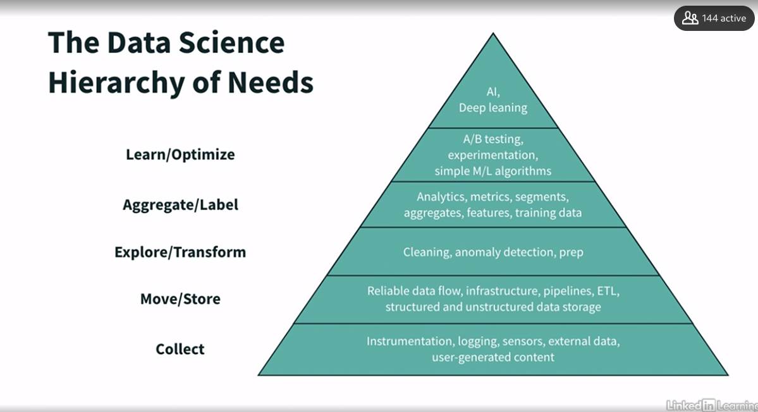

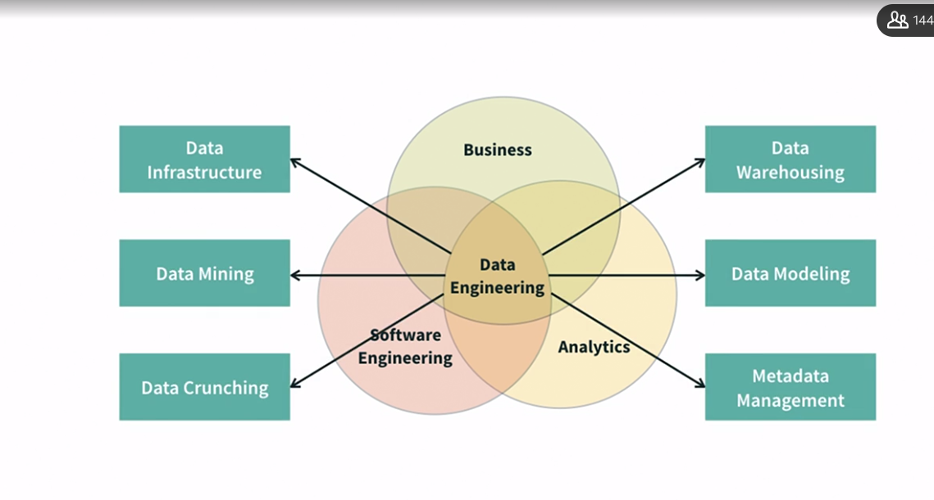

### **Importance of data engineering**

Selecting transcript lines in this section will navigate to timestamp in the video

- [Instructor] You must have heard about Gartner's Prediction back in 2017 that 85% of big data projects fail. This was largely due to a lack of reliable data infrastructures. Data could not be trusted enough to base key business decisions on it. The CEO of IBM said that 87% of data science projects never make it to production. Fast forward to 2019, the things had not improved. Gartner reiterated its prediction that now just 80% of projects will fail, a new one page report produced similar stats. So why is this? What are the key reasons of this prediction? Over the last decade, most companies have completed a digital transformation. This has produced unimaginable volumes of new types of data and much more complicated data at a higher frequency. While it was previously apparent that data scientists were needed to make sense of it all, it was less apparent that someone needs to organize and ensure this data's quality, security, and availability for the data scientists to do their job. So in early days of big data analytics, data scientists were very often expected to build necessary infrastructure, and data pipeline to do their work. This was not necessarily in their skillsets or not expected for the job, which led to incorrect data modeling, redundant work, and inconsistency in use of data among data scientists. These kind of issues prevented companies from being able to extract optimal value from their data projects, so they failed. Today with the onslaught of completed corporate digital transformations, the internet of things, and the raise to become AI driven, it is crystal clear that companies need data engineers in evidence to provide the foundation for successful data science initiatives. Alongside these areas that are key for all data engineers to understand, we believe it is vital from them to be aware of the industry trends that have helped shape the role over the last decade. Some revolutionary advancements are the rise of cloud. Cloud has finally reached a tipping point where even institutions, such as finance and government that have historically shied away, are embracing it. In last four years alone, the market of cloud computing has doubled. The expansion of open source. Data engineering used to be dominated by closed source proprietary tools. Now we are seeing a growth of open source tools and in many cases, a preference for these tools in data organizations. Open source libraries such as Spark and TensorFlow have become widespread and many organizations are seeking to minimize vendor or product locking. The growth of data in scale. The company simply have more data at their disposal now, more than ever before, which makes it more important for data engineers to understand how to scale. More than 90% of world's data was created in last few years. Data engineers need proficiency in tools that can help to quickly organize and assess this massive amount of data.

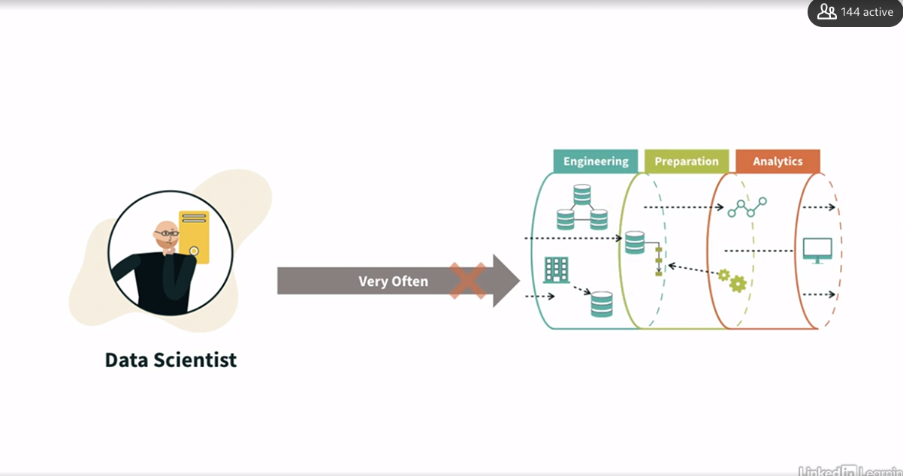

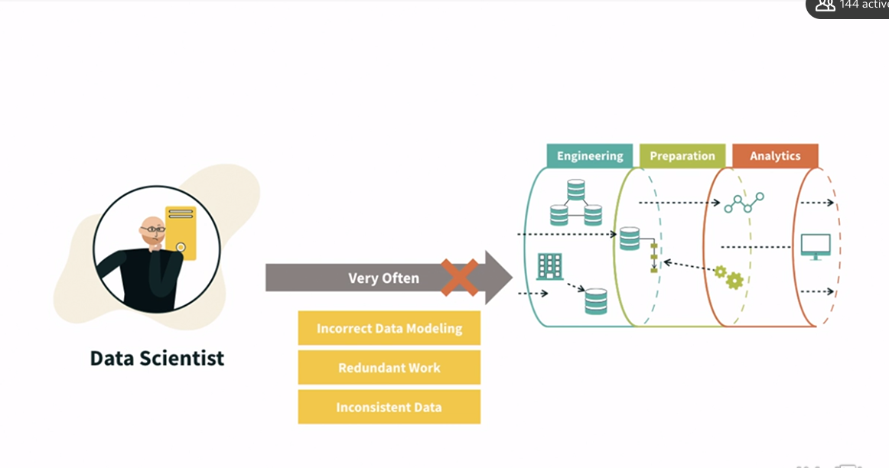

### **Types of data**

Selecting transcript lines in this section will navigate to timestamp in the video

- [Instructor] Data generation has exploded exponentially in last couple of years. In fact, statistics says that 90% of data that we have in this entire planet is generated in last two years and 2.5 quintillion bytes of data gets created each day. Just imagine what would happen in next couple of years from now. So data has been increasing and there are very significant reasons for that. If you look back in 2007 or 2008, there was hardly anything. Not everyone used to carry mobile phones, right? But now you look at it, everyone has more than one device like phones, tablets, and computer or laptop. We take it for granted that everyone must be having mobile and laptop. So there is an enormous amount of information around us. If you just go 15 years back, it was quite unimaginable the way we do things today, like we order food, we book cabs, we take online real-time classes and medical consultations and much more. Have you ever thought that you will be able to do all these via your smartphone? So data is everywhere, and lot of different services and different companies have come up because of this data. We use Netflix, we use LinkedIn, YouTube, Instagram on daily basis. So number of services these companies have built. If you look at it at the nutshell, it is all data. Now, if you are from engineering background or analyst or even machine learning engineer, you would know that data is the core of everything, and almost 70 to 80% time you spend in cleaning the data you get from different sources. So you should have right mechanism so you can clean your data, you can process your data, and can make best use of machine learning models you are going to build. At the same time, it is very important that how you consume this data, especially in real time, for example, police station getting the data from all the sensors for CCTV cameras from a city in case of any issue or any obnoxious task like theft, murder, accident, et cetera, to get into the root cause, they should be able to get hold of right data instantaneously as and when it is needed. When we talk about data, there are three main classifications of data formats, structured, semi-structured, and unstructured data. Structured data refers to the data with a defined data model like SQL databases where tables have a fixed database model and schema. On AWS, for example, the RDS or relational database service is an example of a structured data store. In semi-structured data, we basically have a flexible data model or tagging mechanism that allows a semantic organization and some kind of hierarchy discovery from the data without having the fixed and rigid rules from SQL databases. XML, JSON, CSV files are good examples of semi-structured data. NoSQL databases can also be structured, but usually they are used in flexible way to complement the limitations from Amazon S3 to SQL databases. Amazon DynamoDB allows each record to have a different number of columns, but gives fixed indexes for searching. This provides a very flexible schema. Lastly, we have the unstructured data where all kinds of text information without a data model is classified. Here we have all kinds of documents without a proper data model or a schema like books, natural language processing, and all sorts of text processing.

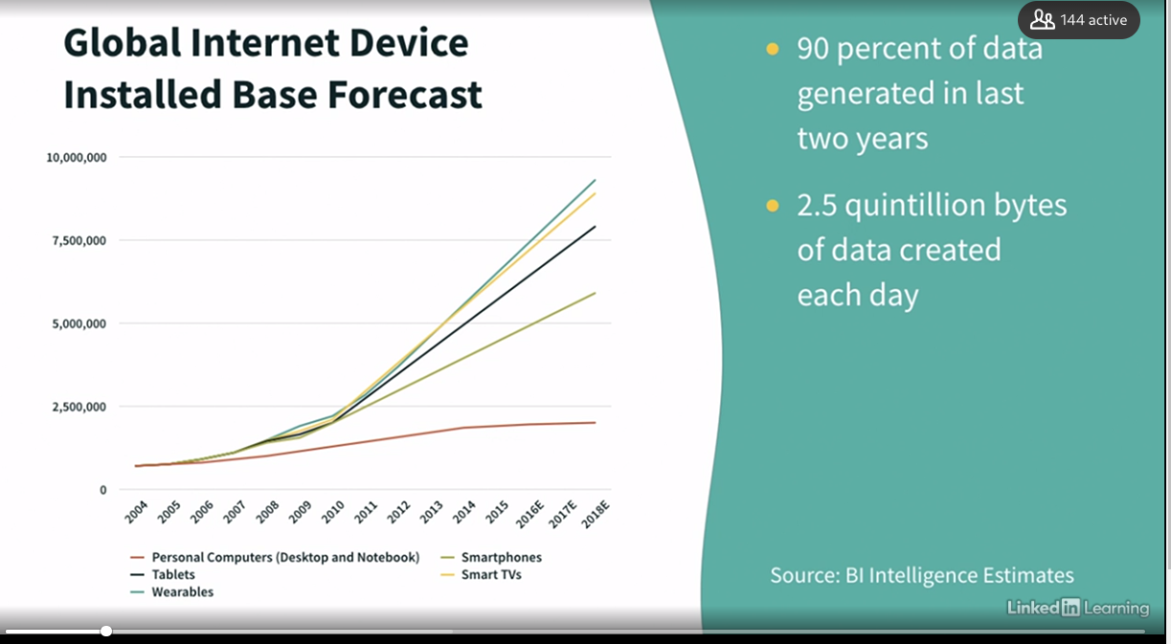

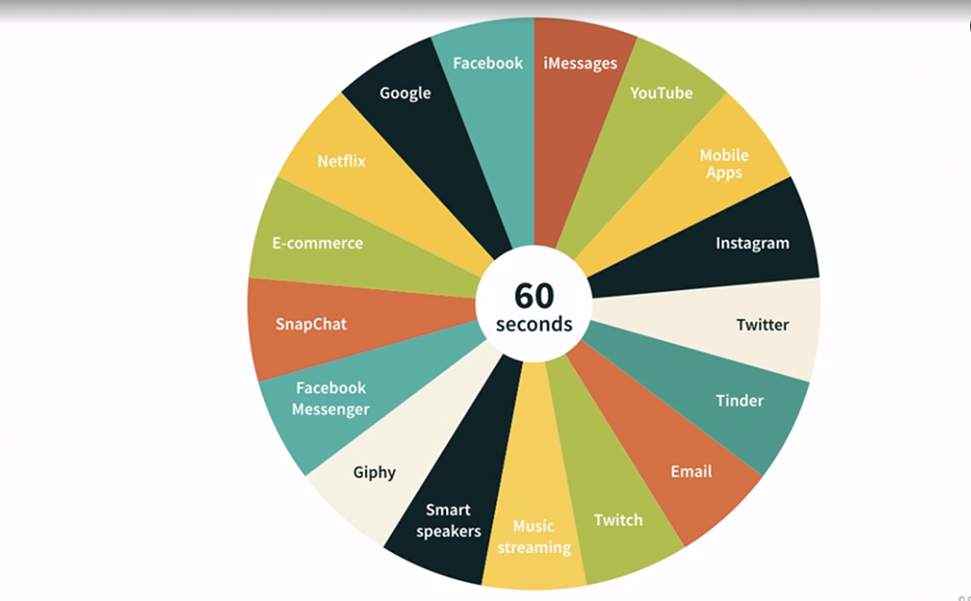

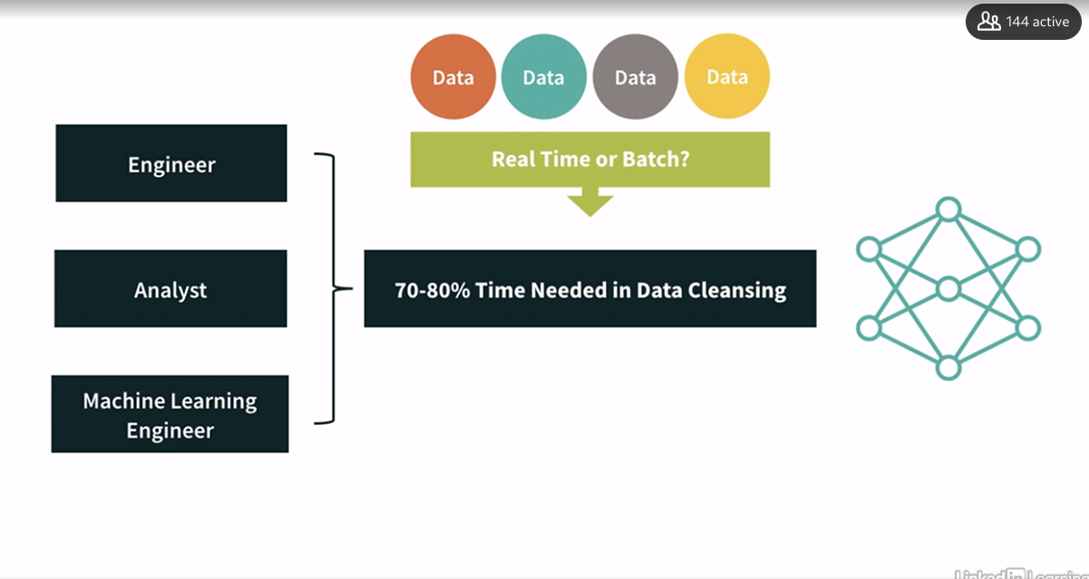

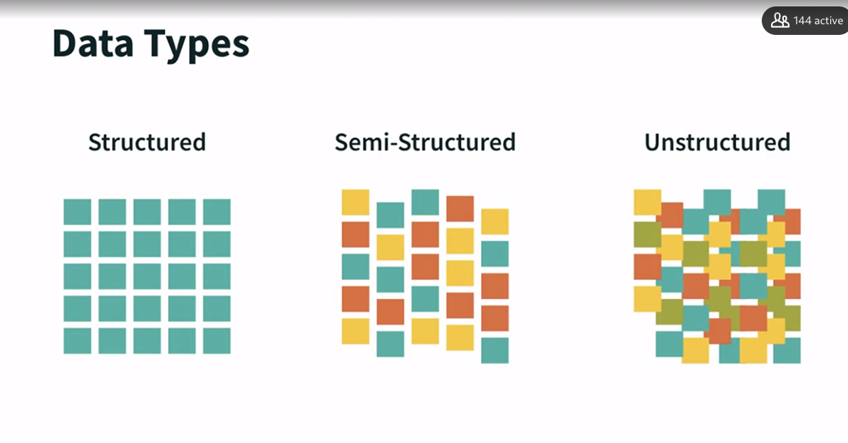

### **Overview of data lakes**

Selecting transcript lines in this section will navigate to timestamp in the video

- [Instructor] Data lake is nothing but a centralized repository that allows you to store your structured and unstructured data at any scale. So we look at it as a repository where we can store structured, unstructured, or semi-structured data coming out of any kind of source. It can be a data coming in a batch mode or may also coming in real time or near real time. There is absolutely no restriction as to what kind of data you store in data lake or how you store data in data lake. Most cool feature of data lake is that you really don't have to think on the use case you want to implement before you get the data in. So you don't need to impose any structure to the data lake. And the best practice is to incrementally build your data lake. Now, let's have a quick look that what advantages data lake on cloud offers apart from the standard cloud benefits like low cost storage, scalability, reliability, et cetera. So it is single source of truth. It means it eliminate data silos and bring everything to the central place. It offers schema on read. As I said, there is no enforcement on writing the data on data lake, only when you want to read data that is when you are putting some structure to it. So there is lot of flexibility. It offers different processing capabilities and quicker ingestion. It also decouple your storage and compute. Another important thing is that it is low cost because you are reducing data duplication across different sources. It also decouples your storage from compute. So imagine that you have your storage here in S3, and then you have some application that might be running on EC2. There is another application that might be running on Lambda. And all these applications are actually consuming the same data. So if you look at it, you are actually decoupling your compute resources with respect to the storage resources. So that is good that you don't have any dependency. Let's say tomorrow, if you have another application to perform some analysis, and let's say it is running on Redshift, you can use the same data for your data warehousing or analysis activities. That is the beauty of decoupling the storage from compute. Now let's look at some of the architectural principles we should follow while designing the data lake. First thing that we have to keep in mind, that it has to be a decoupled system. That means my ingestion, my processing, and my consumption should be decoupled, which means change in one component should not affect the other. And we need to choose right tool for right job. For example, if I just talk about one of the layer, ingesting data, I need to think about what my data structure is. How am I going to access it? How am I going to ingest the data in it? And base is that I will choose the right tool and will not stick to one tool for everything. Another important aspect is identifying hot, warm, or cold data. It essentially means there would be certain data that will be used very, very frequently, maybe for my ETL pipeline or for analytics. It is frequently used, so that's practically my hot data. Then there is data which is used but not that frequently. So that comes into the category of warm data. And the cold data is the one which is hardly used but you need to preserve it for compliance purposes. So accordingly, you need to decide the storage strategy. And we should also leverage managed or serverless services to offload heavy lifting and maintenance of clusters, and focus on business logic. We should design our data lake as immutable, means once it's stored, data should not be modified or deleted. It is also known as event journaling design pattern. There are multiple layers of data in your data lake, like as is, processed, aggregated. So you are maintaining all versions of your data in data lake. And another important aspect is cost consciousness while designing the system. So these are the fundamental things you should keep in mind while designing the data lake.

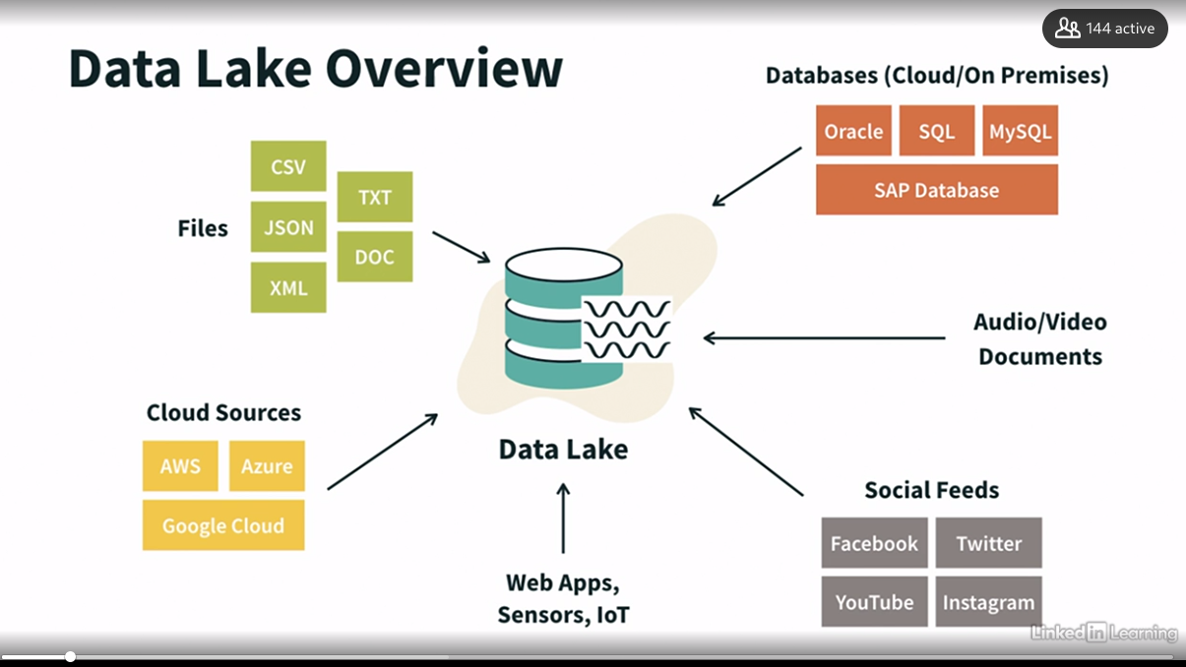

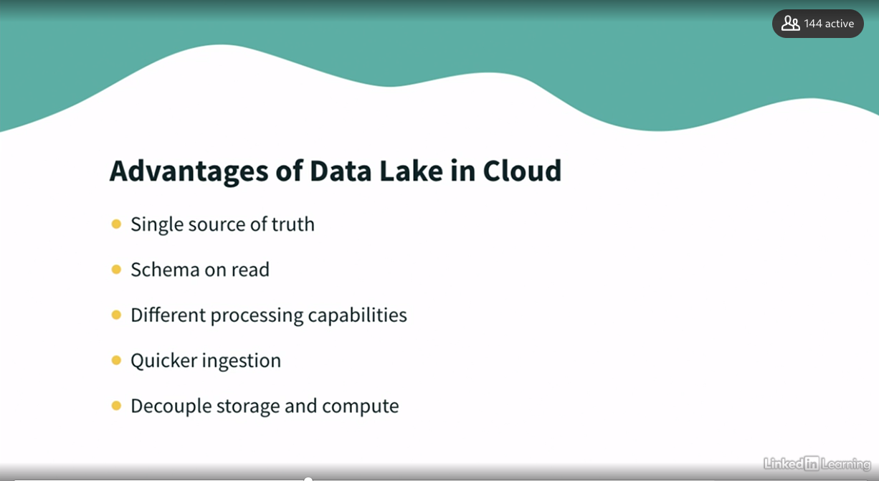

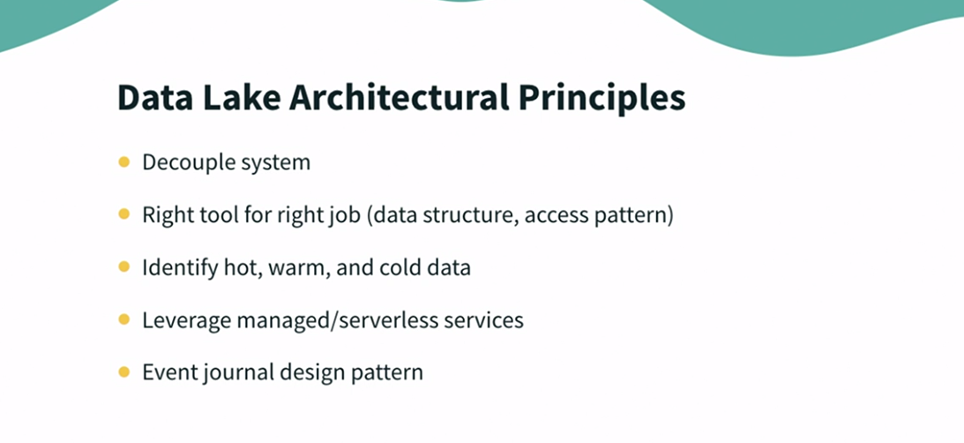

### **Introduction to data engineering pipeline**

Selecting transcript lines in this section will navigate to timestamp in the video

- This is the conceptual view of Data Lake where we have producers. Those are the source systems that are producing the data. Then, we have engineering pipeline in between, which actually crunches the data and does all the manipulations that are needed. And then, we have consumers, which are set of downstream who want access to your data. This is very simplistic view of Data Lake. Conceptually, this is what is happening, but the whole of the magic is happening in the middle layer, which is engineering pipeline because that is where you are doing entire heavy lifting of bringing the data, establishing all the design pattern that you want, and doing the crunching of data and giving it to the consumers. So, that is going to be our focus, that how do we build data engineering pipeline. At high level, these are the different stages in engineering pipeline. That we have a data source from which the data will come in, and then you should have some ingestion where you will consume the data. Then, you will store that data in some storage where you will do cataloging and search. Now, this is important. As you need to understand what data is in there. So, that metadata needs to be in place. Then, you have data processing and analytics. And then finally, you will consume this processed data for various use cases. Let's look at these stages in detail one by one.

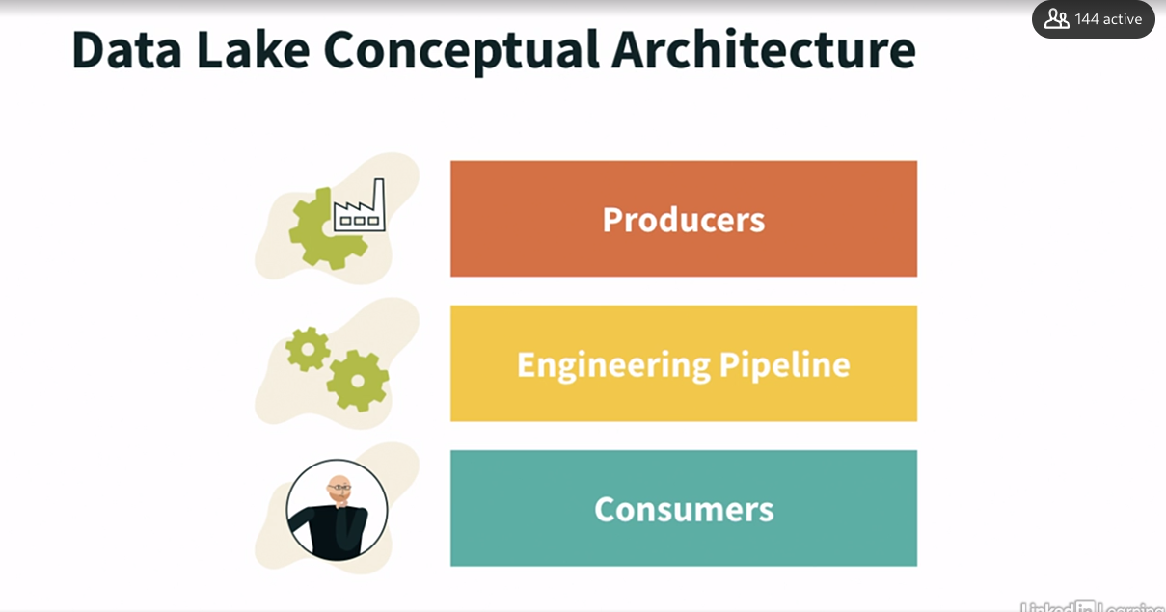

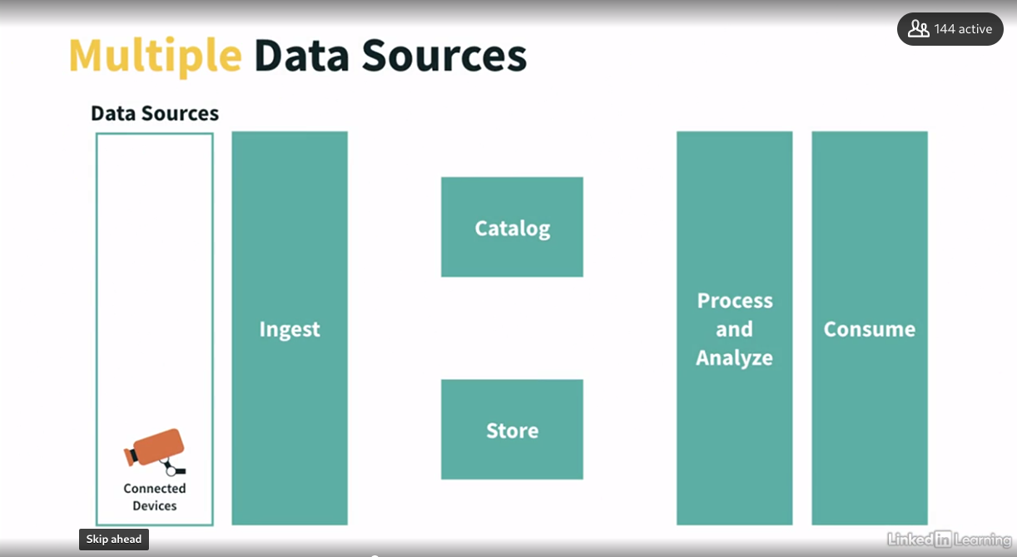

### **ynamoDB overview**

Selecting transcript lines in this section will navigate to timestamp in the video

- [Instructor] Let's imagine you have just built a promising app that world has never seen before. New users are coming in, but can your database scale to handle all the incoming request? Amazon DynamoDB is built to handle internet-scale application as traditional databases cannot handle millions of requests per second during Black Fridays or Cyber Mondays kind of scenarios. You can store hundreds of terabytes of data in DynamoDB and can expect great performance. So let's discuss key features of DynamoDB. DynamoDB is a fully managed, multi-region, multi-master, and highly-available database. And all your data is replicated across three availability zones, and you don't have to worry about patching and upgrading. It's a NoSQL database. That means it's not relational database. Amazon DynamoDB is primarily designed to manage semi-structured data. DynamoDB tables do not have a fixed schema. They are schemaless. So each data item can have a different number of attributes, which is very different to a relational database, which does require the attributes in a table to be consistent. It will scale through massive workload and will be distributed, and that's what make it scale. You can issue on it millions of requests per second. The really good thing about DynamoDB is that you get fast and consistent performance. So that means every retrieval will be low latency, usually in the single-digit millisecond. It will be integrated with IAM for security and authorization which is the best practice in AWS to manage security anyway. On top of it, we can enable event-driven programming for your DynamoDB streams where we can reply to events that happen to our table and see in real time that what we want to do about it. It's low cost and has autoscaling capabilities which makes it the perfect serverless database. Now, let's log in to AWS Console and see how DynamoDB dashboard looks like. So basically, DynamoDB is a database, but you don't need to create databases as they are already there for you. It's made up of tables. So let's create a new table here. Let's name it players. Each table will have a primary key, and you can also define a composite key by including a sort key. So let's define playerid as the primary key and country as a sort key. Each table can have infinite number of rows. And each row may have different number of attributes, which we don't need to define at the table creation, which is in contrast to any RDBMS. The maximum size of a row can be up to 400 kilobytes. However, you can have any number of rows of this magnitude. So this is really important decision while designing for your storage, that what kind of data it holds, as DynamoDB has a limitation of 400 KB while S3 can store objects up to five terabytes in size. So here, either we can simply create table with default settings or can provide customized configurations. And key thing to define here is the throughput you need in terms of read and write capacity units. Read capacity unit or RCU is the number of elements you will read per second, while write capacity unit or WCU is number of elements you will write per second. And you have a capacity calculator here where you can calculate the required read and write capacity. So if your item size is one KB and you want to read and write one item per second, you will need one, one read and write capacity units. However, if your item size is, let's say, 300 KB and you want to read and write one, one item per second, then you will need 38 read capacity units and 300 write capacity units. And worth noticing here that it will also increase the cost. You can also turn on scaling and impose encryption on your DynamoDB data. So let's go ahead and create this table with default settings. And now let's try to add some data in this table. So as we can see here, this table is being created. Let's try to refresh this table. So we can see it is available. And this is where we can create records into this table. So let's say playerid is p01, and it represents country USA. Create this row. Let's try to add another row here with playerid p02, representing country as India. And here, we also want to add another attribute as city, that this player is from Delhi City in India. So here we can see that we have two rows, and both the rows has different number of attributes. So you can have any number of rows in your DynamoDB table with varied number of attributes. Now, you might be thinking that how DynamoDB relate in data engineering? Well, there are some very common use cases. That includes mobile apps, gaming, digital ad service, live voting, audience interaction for live events, sensor network, log ingestion, access control for web-based content, metadata storage for Amazon S3 objects, ecomm, web session management, et cetera. In terms of anti-patterns where DynamoDB is not a good choice for, for example, RDS-like fixed schema, complex joints or complex transactions, or large-size objects. This is a very common pattern. And in general, if you have large data that has low I/O rate, so few write or very few read, then S3 is going to be a much better storage option for you. So the use cases are quite diverse. But basically, that means that any time, if you have some data that need to be very hard, small in size, and needs to be ingested at scale within a database, then DynamoDB is going to be a great fit for that.

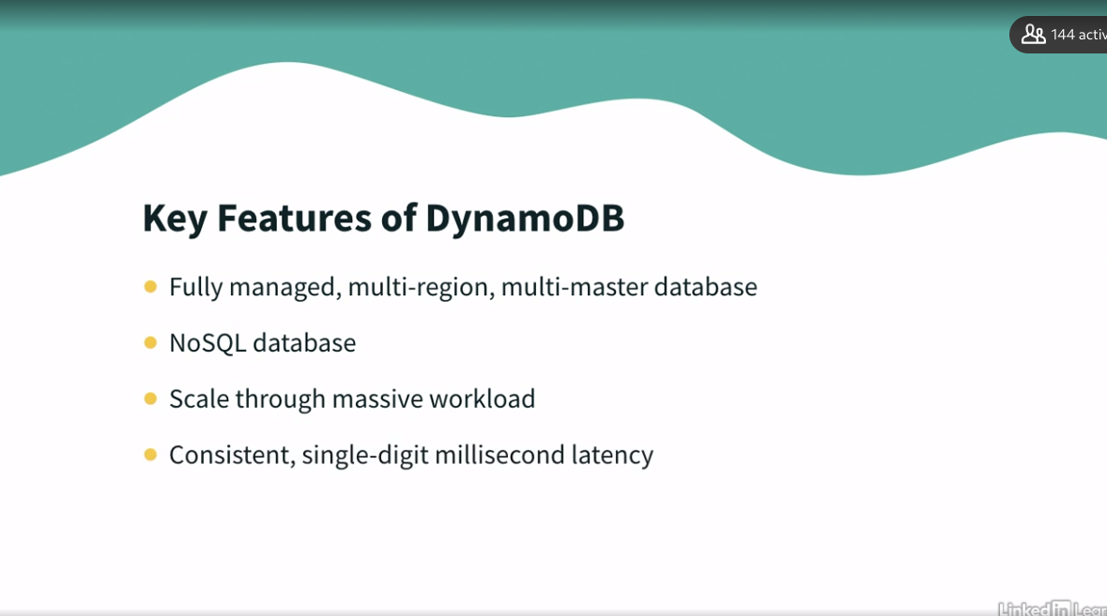

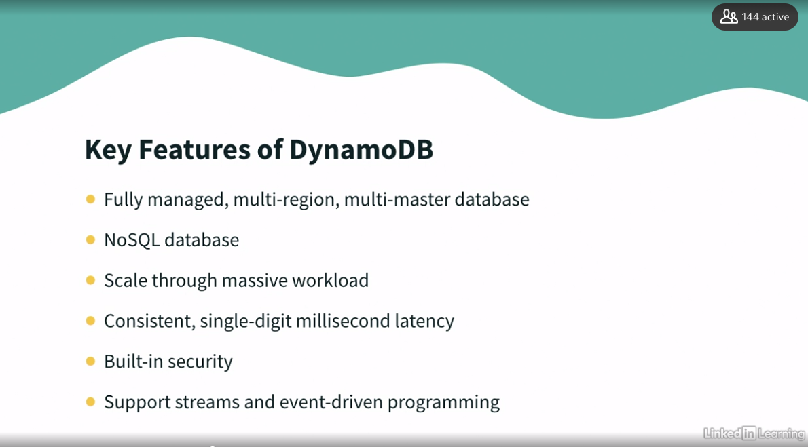

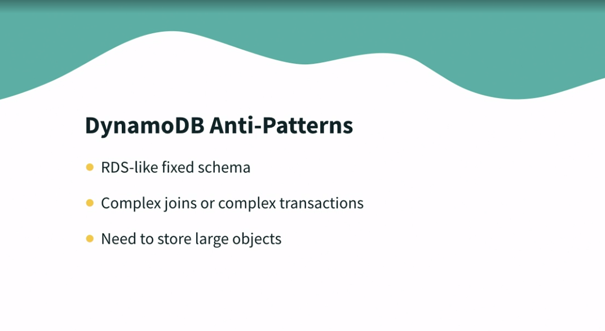

### **Understanding DynamoDB partitions and streams**

Selecting transcript lines in this section will navigate to timestamp in the video

- [Instructor] While working with DynamoDB something you need to absolutely understand especially in big data context, is how the internal of DynamoDB, especially for partition's work. So when you start with DynamoDB, for the table I just created, you are going to start with just one partition and each partition has a boundary. It can have up to 3000 RCU and thousand WCU, and it also can have 10 GB off data. So let's have a look in here. I have a DynamoDB table, which has got three partitions. So we have our item player ID one, and it'll go through a hashing algorithm on the partition key. We are not exactly aware what the hashing algorithm is but what we know is that the same key will go to the same partition. So when the player ID one is being hashed it is being sent to, for example, partition one. And if the player ID one is encountered again, it'll go again to the same partition. Maybe player ID two will go to partition two, player ID three to partition three, and let's say player ID four goes to partition three and five to partition one. But when player ID two comes again it will go to partition two, and so on. So now how do we understand how many partitions we are going to get? Well, basically based on the limit of each partition we can guess the number of partition we are going to get. So there is a capacity which is like total RCU divided by 3000, and plus total WCU divided by thousand. And then by size, you look at the total size of your table is divided by 10 GB and get the total number of partition. So you basically do the max of the capacity which is computed and the size. So for example, if you have like 50 GB of data we should have at least five partitions just to give you an idea. So it's something you should know that the WCU and the RCU will be spreaded evenly between each partition. So let's have an example here. If we have our table setting and we say, okay, in this table we are going to have 6,000 RCU and 2,400 WCU, what does it mean when the WCU and RCU are spreaded evenly? That means that each of these partition is going to get 2000 RCU and 800 WCU. So it's really important to understand this because once you understand how DynamoDB distributes data and based on number of RCU, WCU or size, then you are able to understand the behavior of your table. All right, now let's see, how do we react to the changes in real time into our DynamoDB table? And the answer is using DynamoDB streams. So all the changes in DynamoDB would be, create, update or delete, will end up in a DynamoDB stream if you enable it. That means that the change log of your table goes into a stream and the stream can be read by, for example, AWS Lambda or KCL with adapter. What can we do with these? Well, we can do react to changes in real time. For example, we can send a welcome email to new users from our users table, or we can create derivative table or views. We can also insert data into elastic search et cetera, et cetera. Basically, your Lambda function will receive a batch of records from your DynamoDB stream, and based on that you write in your line of function you can do anything you want. You could even implement a cross region replication using streams if you want to. Now streams such as like Kinesis as you have 24 hours of data retention maximum, you can not set this to be anything else. It has to be 24 hours and you can configure the bit size that Lambda receive up to thousand rows or six megabytes of data.

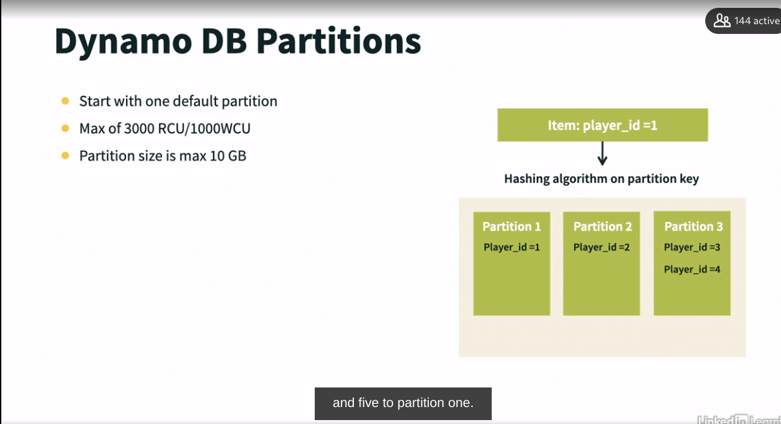

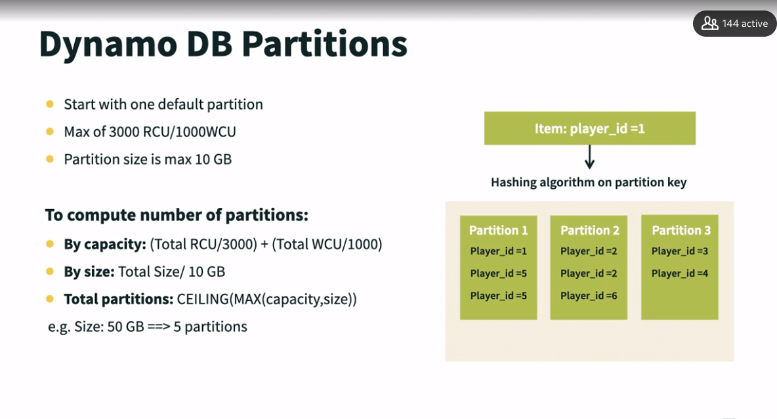

### **Lab: Set up CLI to create DynamoDB tables**

Selecting transcript lines in this section will navigate to timestamp in the video

- Most of the time, data engineers perform their engineering operation via command line interface or in a programmatic way via SDKs. So let's understand how to interact with DynamoDB using CLI. So if you are using CLI for the first time, then you will need to install AWS CLI and then, configure it using aws configure command. Since, I have done it in past, let me quickly verify if configuration is still available. So yes, it is. So we are good to go. So for this, I'm referring script available in my GitHub in dynamodb-scripts folder and a script name is 02_04_Create TableviaCLI. Let's open this script in a notepad. So here, we are trying to create a table using this command. So let's understand this command first. So here, first of all, we are calling aws dynamodb, create-table and then, we are creating a table with name PetInventory. This table contains two attributes. Attribute pet_species is of data type string while attribute pet_id is of data type number. Here we are setting pet_species as our hash key or primary key while pet_id is our range key or sort key. And we are also enabling billing mode as PAY_PER_REQUEST. All right, so let's simply copy paste this command on the command prompt. So it has created this table. Let's quickly verify it on the console. So here I'm on DynamoDB dashboard. Let's check in tables. So, here we can see that this PetInventory table is available. Let's check the items. Since we have just created this table and not inserted any rows, so, this time it is like zero rows. Now, what do you think, when we create item in this table, what are the things mandatory for us? Since we created composite key here, pet_species as our partition key and pet_id as a sort key then definitely, we need to provide at least these two attributes for each row but we can also add additional attributes on our flyer. All right? So let's look at the other commands here. So you can also describe table using DynamoDB describe table command. You can also list table in your account using list-table. Let's see that in action. So here, it has listed all the tables present in my account and you see PetInventory is here on the top. Now, if you want, you can also delete this table using command prompt. So, this has deleted this table. Let's quickly observe it in our dashboard as well. So here it is still showing it active; Let's try to refresh. So now we can see that PetInventory table is gone. So, means it has been deleted. So I hope you're finding it very simple to interact with AWS services using CLI.

### **Lab: Create DynamoDB tables via Python script**

Selecting transcript lines in this section will navigate to timestamp in the video

- [Instructor] Now let's learn to interact with DynamoDB in a programmatic way. Now, since Python is the most preferred scripting language for data engineers, let's learn to use Python SDK. So in Python, Boto3 is the SDK to interact with AWS. So needless to say, you will need to install Python as well as Boto3. Now let's switch to our editor. Here, I'm using Visual Studio Code as my editor but you are free to use any editor of your choice. So here, I am in folder DynamoDB scripts under my GitHub. So here if you notice, I have couple of scripts with extension .py. These are the Python script. To execute these scripts, we will need to ensure that AWS CLI is configured and Python is installed. Let's quickly verify that. So, yeah, CLI is configured and now let's check the Python. So we can check it using Python version. So we can see Python 3 is installed here, so we should be good to go. Now let's check this script. What this script is doing, that first of all we are importing Boto3 library and then we are creating a function with name, create movie table and passing table name as parameter here. Now this line is very important. What it is doing, it is creating DynamoDB instance using Boto3 client. And when we are creating this table, what we are doing, we are creating two attributes, year and title. And these will be our partition key and sort key respectively and data type for these attributes, numerical, string. And we are also defining provisioned throughput of 10. 10 RCUs and WCU. Till this point, we have just defined our function. We have not executed that. In order to execute this function, we will need to call it explicitly. So here at this line, we are calling this function with table name parameter's value as movies and then we are returning its status and printing the status. Now let's run this script. In order to run any Python script, we will need to write Python and then script name. So here it has printed the status creating and then exited. And exactly that's what I have done in my script that after printing the status, script is over. So how to verify that it has actually created the table. I think best way to check via console. So let's go to our DynamoDB dashboard and try to see if it has created a table here. So we can see it has created a table with name movies and it has provisioned throughput 10 and it has partition key as year and sort key as title. Now let's try to check the items in this table. So here we can witness there are no items. Means it has just created an empty table. Okay, so now let's try to insert some data in here. For that, let's review our second script which is to load data. So what this script is doing, from there it is loading data from this file. This is a JSON file which is present right here in the same directory. So this JSON file contains large number of data. So what I'm doing here in this table, I'm simply inserting first 100 rows, all right? So let's try to execute this script and see. Sorry, I want to load data. Let me list the files again and pick the correct one. So if I say Python and then load data script, so here it is adding these rows into our table as we have instructed to load 100 rows in the table. So we can see it is adding rows with year as 2013, 2014, 2012, and movies name. So this script is now complete. Now let's go back to our console and try to refresh this table and see if we can see any rows in here. Not yet. So now we can see some data in our table. Let's verify our next script which is to query data. So in this script, we are trying to query this table, movies. We are trying to query this year that if query year is 2013, then please return that data, okay? So let's run this script. And process is same to run the script, that Python and the query script name. So here it is returning the movies with year 2013. So this is how you can query selective data from your table via Python. And now in this script, we are simply deleting the table. So here, if I run this script, what it will do, it will simply delete the table which we have just created. Let's do that. And it is always a good practice to delete your resources whenever you are creating them for practice. So here we have passed the table name as movies, means we are instructing it to delete movies table. So we can see it has deleted the table. Now let's verify it on the console as well. So if we go back to DynamoDB dashboard, we can see movies table is no more available here. So that's how it is a great way to interact with AWS using SDK.

### **Challenge: DynamoDB**

Selecting transcript lines in this section will navigate to timestamp in the video

(upbeat music) - Now, since you have learned to use Python SDK to interact with AWS, I have a small challenge for you. I want you to perform CRUD Operations on a DynamoDB table. So what all you need to do, first of all, you will need to create a table using AWS management console. So, you need to create a table with name employees and it should be having primary key as name with data type string. And it should have sort key as email with data type as a string. And you need to create it with the default mode. Once you have created the table, you need to perform create. So you need to create one row, one item into this table you have just created. And for this, I want you to use this Boto3 SDK. All right, so you need to create a record with name as Mark Wilber and email as markwilbur@dataengineer.cloud and department as IT. So after you have inserted this record, next you need to read this record. So, try to read all the records with name Mark Wilber and email as this. So, obviously it will return one row. All right? Then, try to update this record. Try to change the department for this particular record from IT to finance. Once you have updated it, just delete this record. This is specific one which has name as Mark Wilber and email as this. So, I think it is pretty easy. Would you like to give a try? Just to help you with some initial setup and hints, what I have done, I have created some start scripts here as a template for you to start. Okay? So, I have created all these mandatory lines for you that we are creating. We are using this table, employees and then you need to provide those values here. So, if you provide these values here correctly, it will insert the recording table. Similarly, you can read this record using this is script template, and then you can update this specific item and provide your update expression here. Here you can update your record, update the department from IT to finance. And lastly, using this script template, you can delete that specific item which has key as name and email as sort key. So, you need to provide those specific values here to delete this record. Try this out. I'm sure you will feel more confident after you are done with this.

### **Solution: DynamoDB**

Selecting transcript lines in this section will navigate to timestamp in the video

(pleasant electronic music) - [Instructor] I believe it was fairly easy challenge for you, but in case something gone wrong or you struggled on any of the operations, here I have the final scripts for you so you can refer these scripts to verify your solution. So here I have a script for all the four operations, scrub, create, read, update, and delete. So please refer to these scripts in case you find it challenging at any point in time.

### **Data ingestion overview and design considerations**

Selecting transcript lines in this section will navigate to timestamp in the video

- [Instructor] Data ingestion is simply, ability to ingest multiple types of data, and they may have varying ingestion patterns, like, real time data coming from databases or streaming devices, near real time or batch. So how do you want to ingest them? What are the things we should consider when we are designing or putting in architecture for data ingestion? So, certain things we need to keep in mind are that what type of data is coming in? As in, it is important to that what kind of data to be ingested, whether it is structured, semi-structured or unstructured, and how this data is coming? Is it coming in files like XL, JSON, CSV that need to be taken care of. And this will tell you how you are going to setup the ingestion or integration architecture. Then you need to know the frequency in which you want to ingest that data. Whether the data is going to be pushed to your storage, let's say S3 location, or you are going to pull that data from source system, because that will help you understand that what tool you need to use to ingest the data. So these are the very basic things you need to look at. And then comes certain other things that you should also keep in mind that what should be the optimal size of your data? Let's say, you are ingesting data and you are getting incremental data, which is in few KBs. Then it'll not be very efficient to store multiple files of just few KBs because when you will try to read that that will become the performance bottleneck. So ideally, you need to have optimal size. AWS recommends that it is between 16 MB to 256 MB. And if your data is not coming in that size, as let's say, it is coming in KBs then you need to think of doing compaction of that. So try to compact those smaller files into bigger chunks so that your processing is optimized. Then the next thing is file format. Typically, file formats like PARQUET and ORC, they're very good because they're splittable, compressed and they're columnar, so that they're much more efficient. So let's say, your data is coming in JSON or CSV, you can convert them in PARQUET and then store. Next important thing is partitioning. As it plays a vital role in performance while querying or processing the data and definitely the ingestion patterns, like I said, we need to understand the nature of data and decide the right tool.

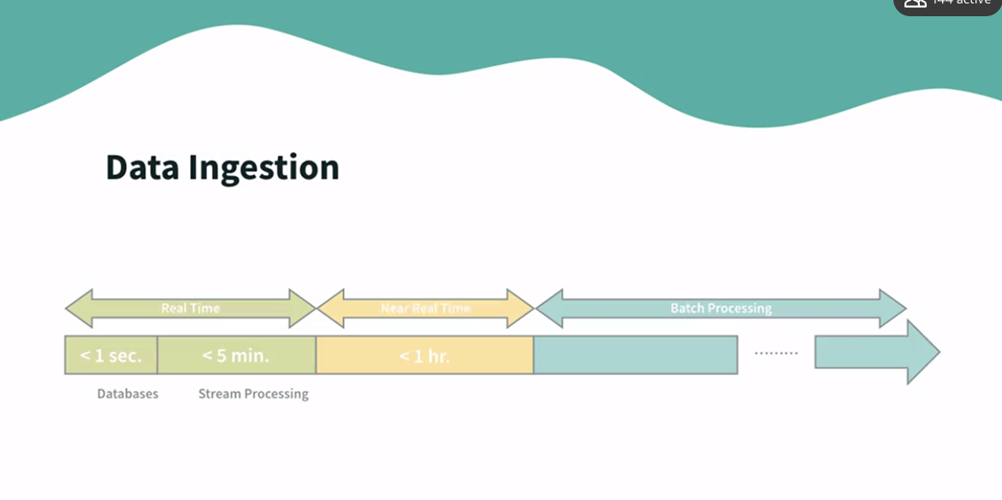

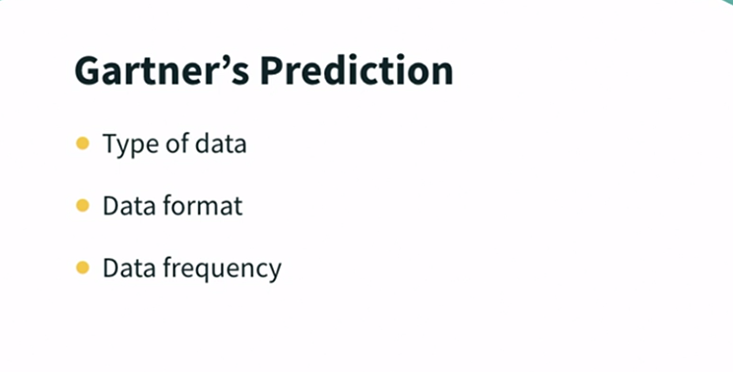

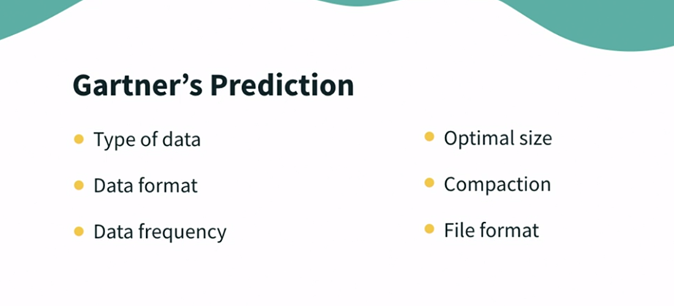

### **Ingestion technology landscape**

Selecting transcript lines in this section will navigate to timestamp in the video

- [Instructor] Now, when we talk about ingestion, there can be multiple scenarios. For example, if somebody wants to create a data lake into the cloud, or most of the time, we have seen that customers don't want to re-architect the whole thing. They mostly prefer hybrid scenario where they have certain technology stack all the way running on-premise, plus they want to go to the cloud to leverage scalability and resiliency. **Then, it's a hybrid kind of approach. Then our strategy of ingestion and choice of tools will be different, as we have to maintain both setup, the cloud and on-premise, and they both have to talk to each other, so there is something called data connect.** **It's a least dedicated line. It's a private connection that AWS establishes with your on-premise. As you don't need to go via internet, it is much faster. It is efficient, and it is secure. So that is one option. Another option is a storage gateway. It's like a software appliance, which you need to install at your end, and you can use it for storing and communication with cloud.** So both these services are very useful for hybrid kind of setup. Then, second kind of setup can be where you want to have a migration use case because there would be a lot of data customer already has on-premise, and if you want to shift to the cloud altogether, and there is no hybrid setup, then in that case, there might be terabytes of data that you want to migrate to the cloud. That's like a historical one-time load, and then you will build a data pipeline to bring in incremental loads and populate your data lake, but for that migration to happen, there are multiple things that we can do. One is Amazon offers a Snow family of products like Snowmobile, et cetera, so what it does, it's a hardware device that is shipped to your location, then data can be put into this device and shipped back to Amazon so that way, you are not transferring terabytes of data over internet, so that is one option. Another option can be data migration service, DMS. It's important when you want to move your data from existing RDBMS to cloud storage. DMS will help you transfer your data from on-premise to cloud very easily. It's a managed service. Simply, you have schema conversion tool. You may have all the data in store procedure, and there is a schema, which you already have and want to migrate to cloud. Then, schema conversion tool really helps to handle this, and there are other services like data sync, so all in all, there are dedicated migration services which can help you store entire migration or hybrid setup, but generally, when you talk about establishing your everyday ETL pipeline, then there would be scenarios that you have to consider, like whether your source system is a batch system or a real-time. If it is a batch system, **there are many traditional ways to ingest that data. You have AWS Glue jobs to bring in the data. You may have smart programs or any third-party tools, but if you want to ingest real-time data, then you need to have a different set of tool, and that is the tool which Kinesis family in AWS provide. When I say Kinesis family, there are multiple Kinesis services like Kinesis Streams, Firehose, so depending on your need, you will choose that to ingest real-time data. Similarly, there is a managed service for Kafka as well, so either you go with Kinesis or Kafka for doing the real-time ingestion.**

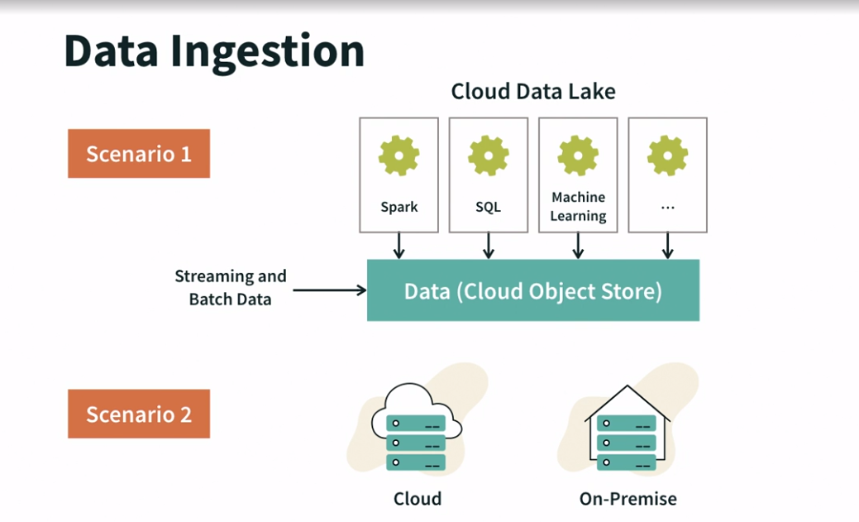

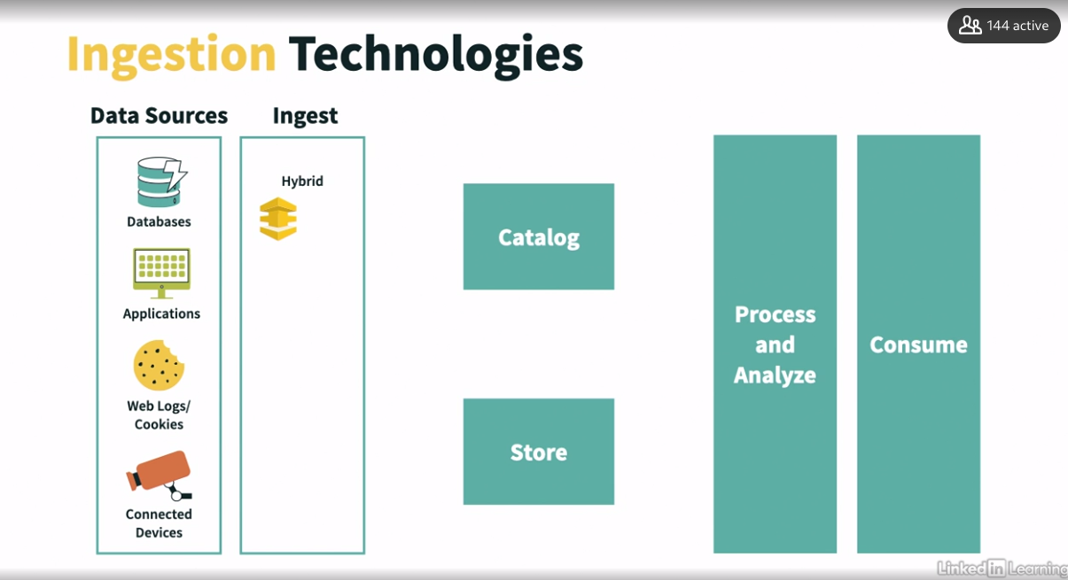

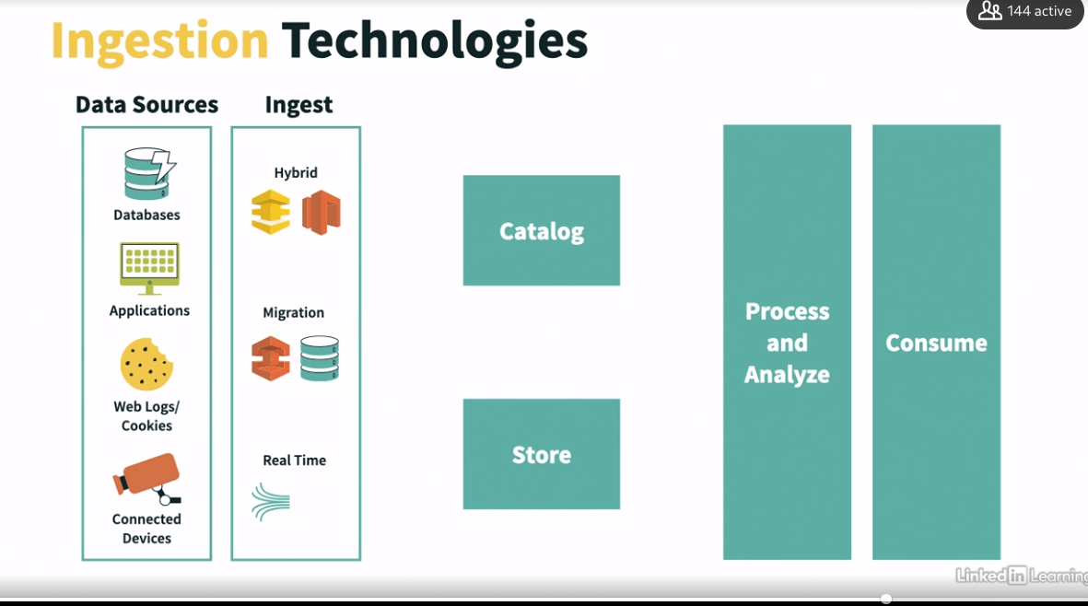

### 

### 

### 

### **Kinesis Data Streams overview**

Selecting transcript lines in this section will navigate to timestamp in the video

- [Instructor] Amazon Kinesis was designed to address the complexity and cost of streaming data into AWS Cloud. Kinesis makes it easy to connect, process, and analyze various types of data streams, such as event logs, social media feeds, clickstream data, application data, and IoT sensor data in real time or near real time. **Access to Kinesis is controlled by IAM. Using KMS, data is automatically protected in the stream as well as when it is placed inside an AWS storage service such as S3 or Redshift. Data in transit is protected using TLS, the transport layer security protocol. Amazon Kinesis is composed of four services: Kinesis Video Streams, Kinesis Data Streams, Kinesis Data Firehose, and Kinesis Data Analytics. Kinesis Video Stream is used to do stream processing on binary-encoded data, such as audio and video. Kinesis Data Stream, Data Firehose, and Data Analytics are used to stream Base64 text-encoded data. This text-based information includes sources such as logs, clickstream data, social media feeds, financial transactions, in-game player activities, geospatial services, and telemetry from IoT devices.** Using Kinesis Data Streams, the process looks like this. Data is generated by one or more sources, including mobile devices, electricity meters in smart homes, click stream, IoT sensors, or logs. Using Kinesis Data Stream, data is collected by one or more producers formatted as data records and putted into a stream. **The Kinesis Data Stream is a stream storage layer and is a high-speed buffer that stores data for minimum of 24 hours and 365 days; 24 hours is the default. Inside Kinesis Data Stream, data records are immutable; once stored, they cannot be modified. Updates to data require a new record to be putted into the stream. Data is also not removed from the stream; it can only expire. Stream processing is managed by consumers. Consumers are also known as Amazon Kinesis Data Stream applications and process data contained inside a stream. Consumers send data records to their destination. This can be something like a data lake, data warehouse, digital storage, or even another stream. Amazon Kinesis Data Stream is a highly customizable streaming solution available from AWS. Highly customizable means that all parts involved with stream processing, data ingestion, monitoring, scaling, elasticity, and consumption, are done programmatically when creating a stream. AWS will provision resources only when required. One important takeaway here is that Kinesis Data Stream does not have the ability to do auto-scaling. If you need to scale your streams, it's on you to build it into your solution. To facilitate the development, management,** and usage of Kinesis Data Streams, AWS provides APIs, AWS SDKs, CLI, the Kinesis Agent for Linux, and Kinesis Agent for Wind

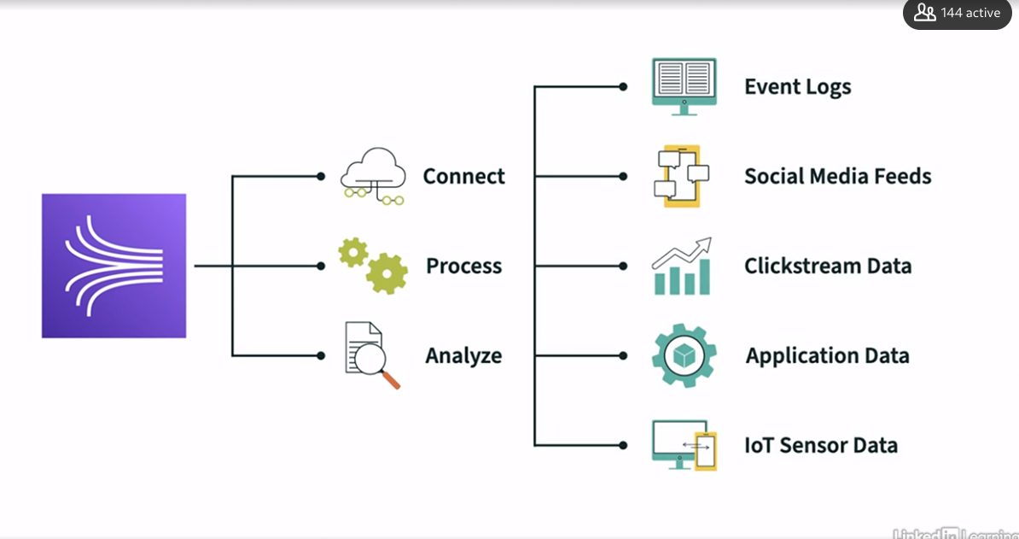

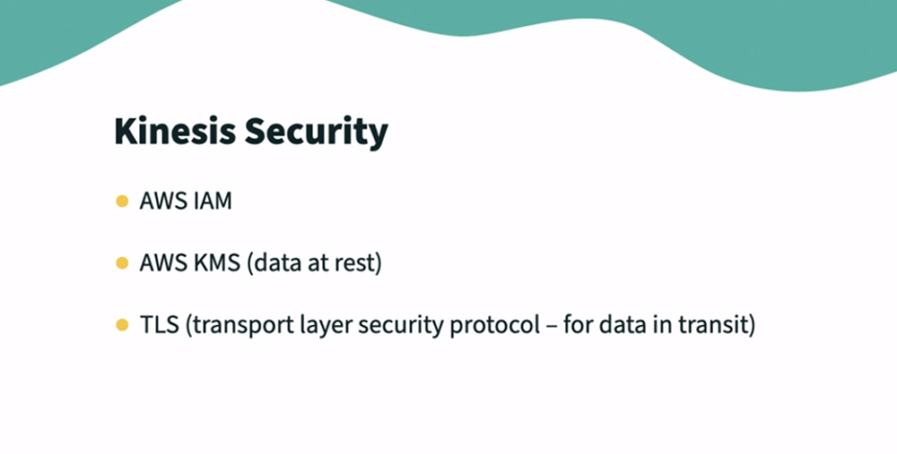

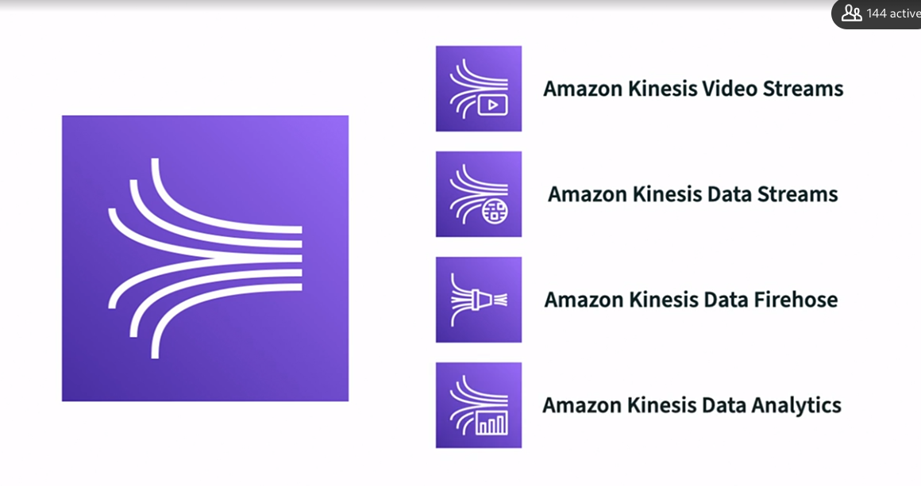

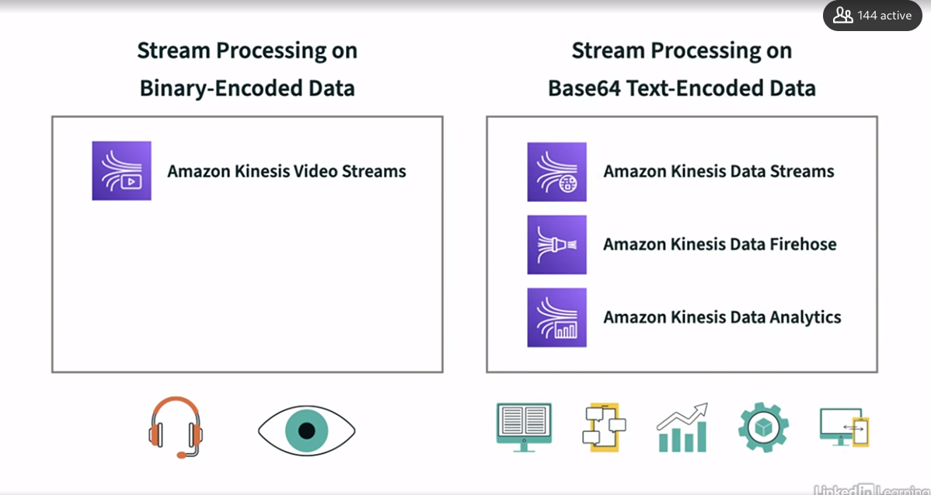

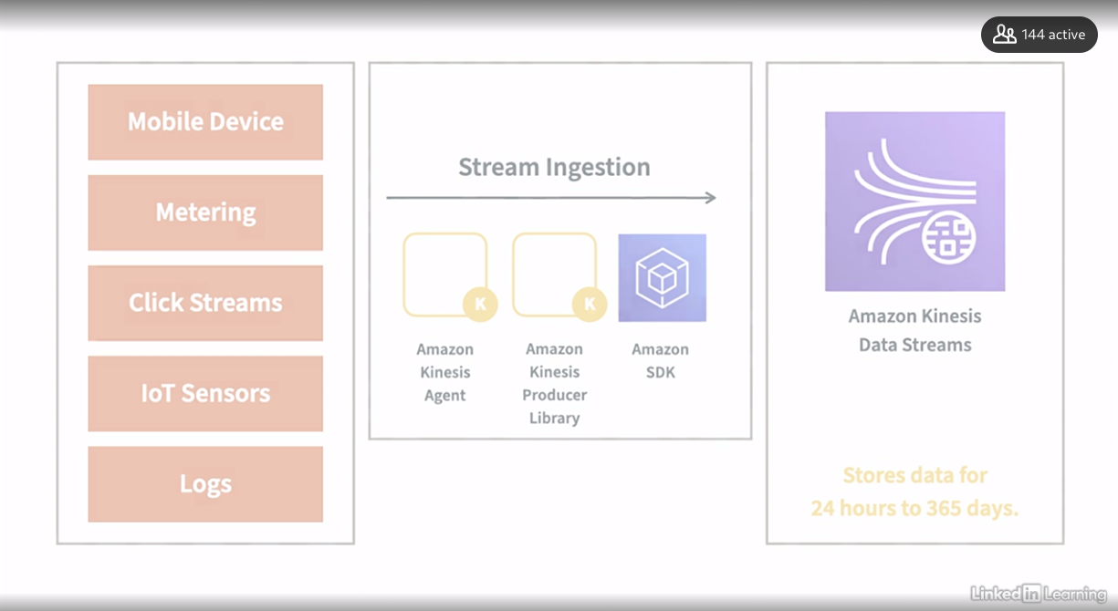

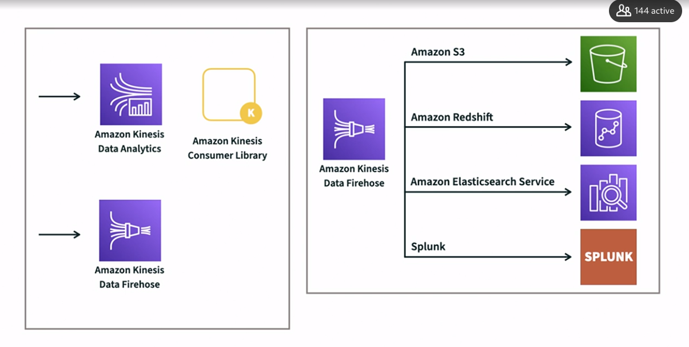

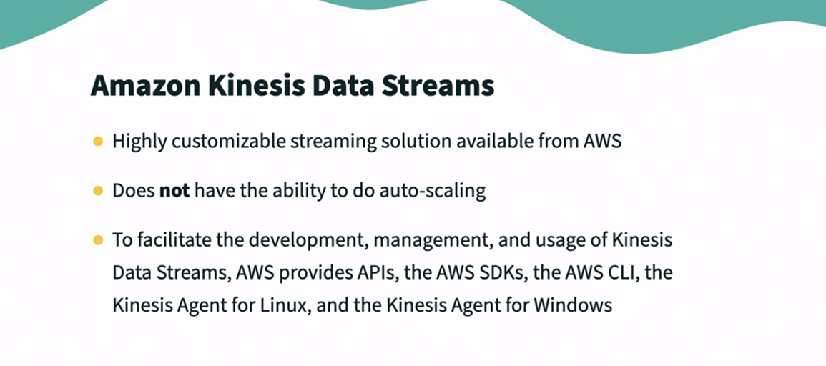

### 

### **Kinesis producers and consumers**

Selecting transcript lines in this section will navigate to timestamp in the video

- [Speaker] Kinesis producers put data records into data stream. Kinesis producers can be created using AWS SDKs, Kinesis agent, Kinesis APIs or Kinesis Producer Library that is KPL, and finally you can use third party libraries that usually build upon SDK such as Apache Spark, Kafka Connect, et cetera. Originally the Kinesis agent was only for Linux. However, AWS has released Kinesis agent for Windows as well. A Kinesis data stream is divided into shards. Shard is an equivalent of a partition. So what does it look like? Well, we have our producer and it's going to produce to a stream in Kinesis. But that stream is actually made up of shards. So for example, here we have three shards and then consumers will read data from shards. By default, Kinesis streams does not store your data forever. It stores it for 24 hours by default. So you basically have one day to consume that data but if you want to increase safety and obviously it would be more expensive, you could retain that data for up to one year. So this is something you can configure. Kinesis is really nice because you have ability to reprocess and replay data. So once you consume that data, data is not gone from Kinesis stream. It will be gone based on the data retention period. But you are able to read the same data over and over and as long as it is in the Kinesis stream. So that means that multiple application can consume the same stream which enables us to do real time processing and you have huge scale of throughputs. The retention period is configured when creating a stream and can be updated using IncreaseStreamRetentionPeriod and DecreaseStreamRetentionPeriod API calls. There is also a charge for retrieving data older than seven days from a Kinesis data stream using GetRecords API call. There is no charge for long term data retrieval when using the Enhanced Fanout Consumer using SubscribeToShard API. Now let's talk about consumers. Amazon Kinesis data stream applications get records from Kinesis data streams and process them. Custom applications can be created using AWS SDKs, Kinesis API or KCL, that is Kinesis Client Library. There are two types of consumers that can data from a Kinesis data stream. The classic consumer will pull data from the stream. It also described as pulling mechanism. There is a limit to the number of times and the amount of data consumers can pull out of a shard every second. Adding a consumer application to a shard, result in having to divide the available throughput between them. As of version 2 of KCL, there is now a push method called enhanced fan out. With enhanced fan out, consumers can subscribe to a shard. This results in data being pushed automatically from the shard into a consumer application, because consumers are not only pulling the shard for data, the shard limits are removed and every consumer gets two megabytes per second of provisioned throughput per shard.

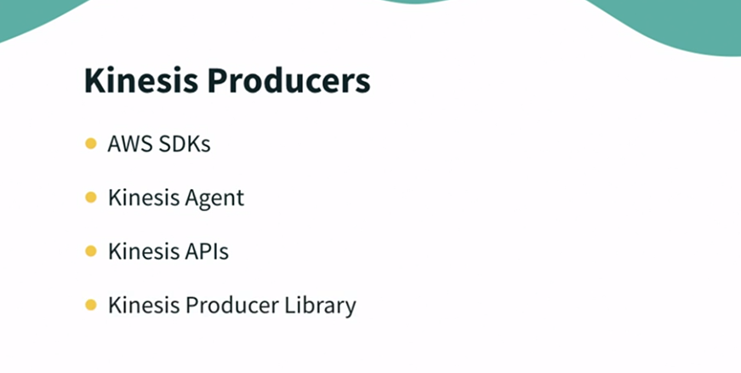

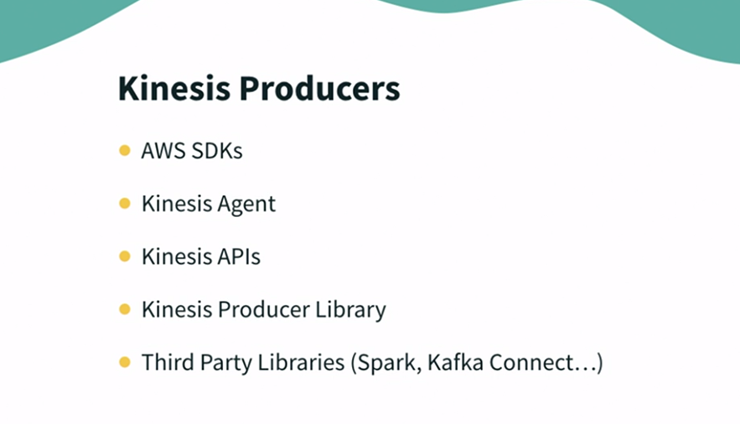

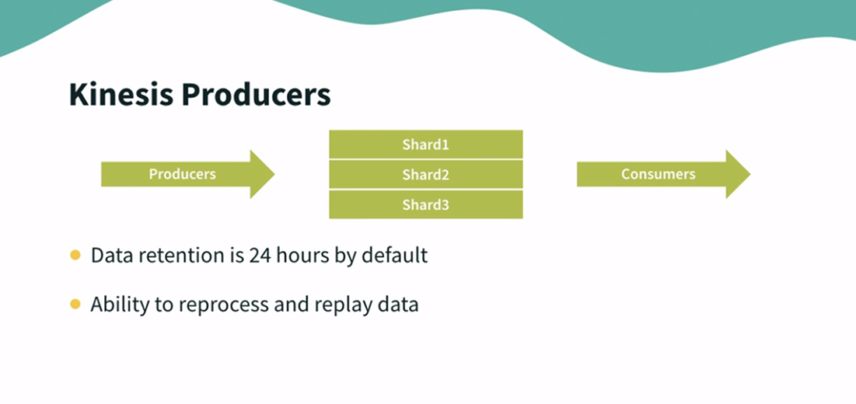

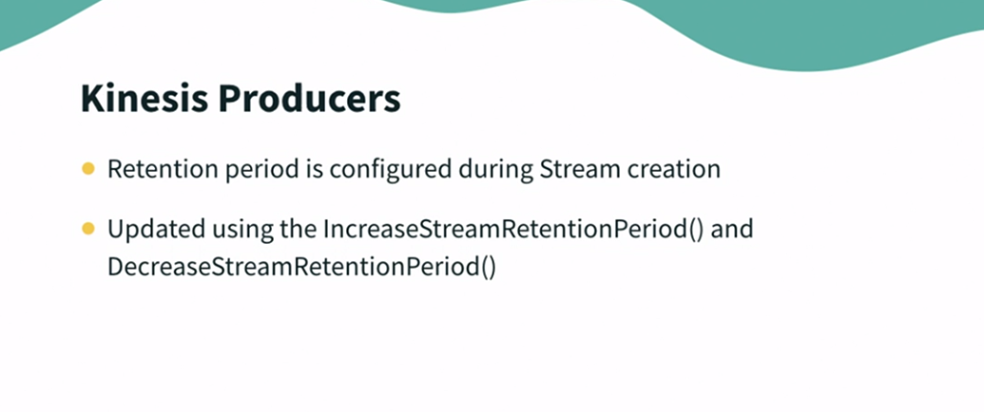

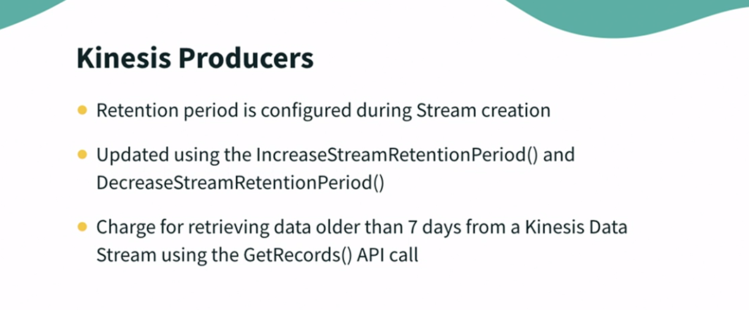

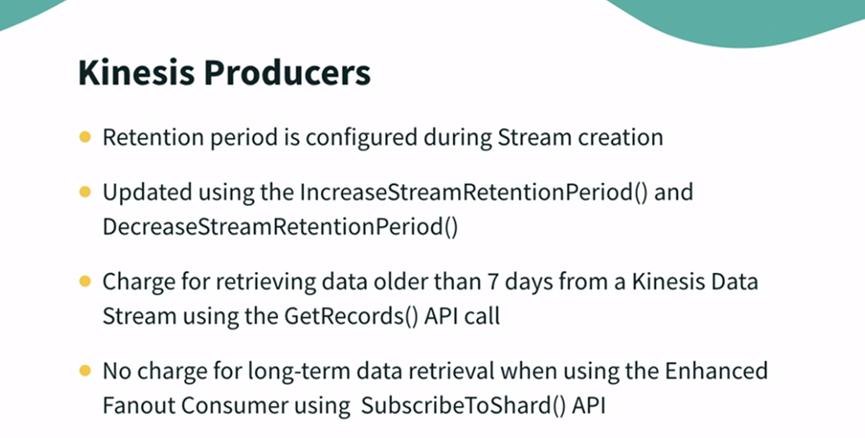

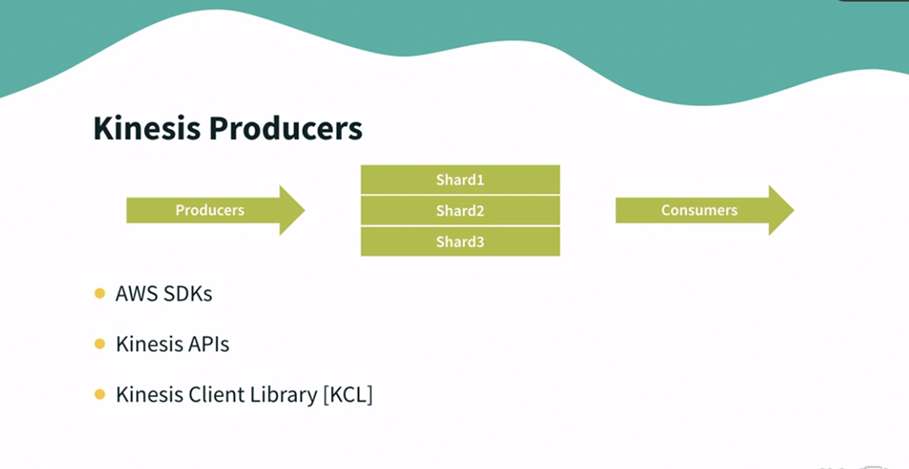

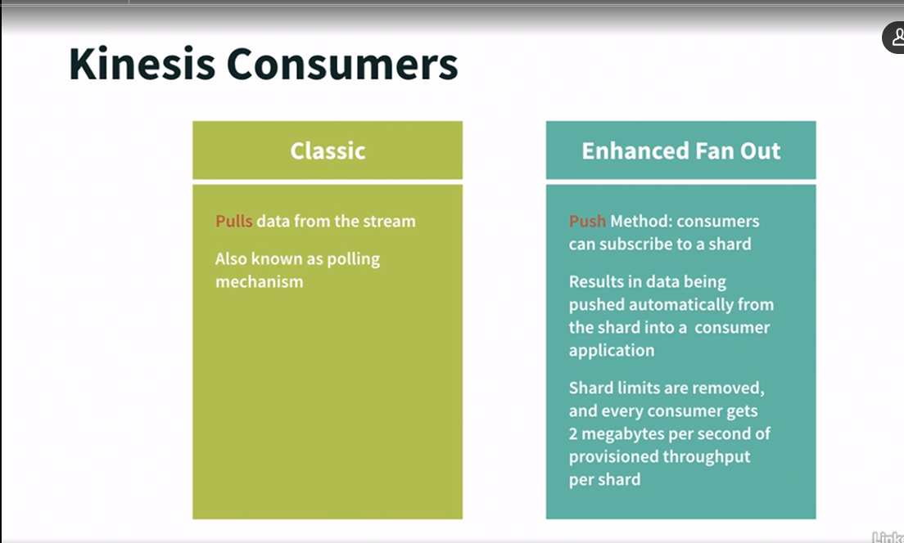

### **Kinesis Data Firehose**

Selecting transcript lines in this section will navigate to timestamp in the video

- [Instructor] Amazon Kineses Firehose is a fully managed service for delivering realtime streaming data to destinations such as Amazon S3, Amazon Redshift, Amazon Elasticsearch service, and Splunk. Kinesis Firehose can read it from your Kinesis Data Stream, from CloudWatch or IoT, but the most common we are going to see it's going to be Firehose reading from Kinesis Data Streams. So it's going to read the records one by one up to 1 megabyte at a time. And if you want to transform the record, we could have a Lambda function created to transform that record to do small modifications. And then Kinesis Firehose will try to fill big batch of data to write that data into a target database or target destination. So that is why it called batch writes. It doesn't write stuff instantaneously. It will try to batch them, to write them efficiently. So therefore Kinesis Firehose is a near realtime service. So in terms of destinations, we have Amazon S3, Amazon Redshift. And to write to Redshift, Kinesis Firehose will first try to Amazon S3 and then issue a copy command into Redshift. Other destinations include third party destination from partners such as Datadog, Splunk, New Relic, and MongoDB. But there could be others coming up in future. As long as there is a valid HTTP endpoint as an API, you can have Firehose deliver data into that destination. And finally, if you have failure for processing or want to archive your data going to Firehose, it's very much doable. You can send all or just subset of data into backup S3 bucket from Kinesis Data Firehose. AWS Kinesis Firehouse is a fully managed service. It does not require any administration and it's a near realtime. So you have to remember this. While Kinesis Data Stream is a realtime, Kinesis Firehouse is called near realtime service and there is a 60-second latency if your batch is not full. So we don't have the guarantee the data will be right away in the destination. There is a near realtime thing with Kinesis Firehose. The really cool thing about Kinesis Data Firehose is that unlike Data Streams, there is automatic scaling. That means if you need more throughput, Firehose will scale for you. And if you need less, it will scale down for you as well. It also supports many data formats and also able to do data conversion. For example, JSON to Parquet, or ORC if you use S3. Other data transformations you can do are done through AWS Lambda. For example, if you want to transform a CSV into a JSON, we could use AWS Lambda to do that transformation. Coupled with Kinesis Data Firehose, it also supports compression when the target is Amazon S3. So we are able to compress that data being sent into GZIP, ZIP, or a SNAPPY directly into S3. And if you load it into Redshift further, then GZIP is going to be the only supported conversion mechanism. Finally, you are going to pay for the amount of data that goes through Firehose. And so the real cool thing about Firehose is that you don't need to provision Firehose in advance and you don't get billed for provision capacity. You just get billed for used capacity. Now we are going to look into how often Kinesis Data Firehose sends the output data to the targets. And for this, we need to understand the Firehose buffer sizing. So how does Firehose work? Well, Firehose will create a bunch of records from the sources and will accumulate all these records into a buffer. And that buffer, hence it name, is not flushed all the time. It's flushed based on some rules. It's based on time and size. So you need to define a buffer size, for example, 32 megabyte. That means if you have enough data coming from source that reach and fill a buffer size of 32 MB, then automatically it is going to be flushed. The other setting is buffer time. So for example, two minutes. That means, if after two minutes your buffer size is not full, nonetheless, is going to be flushed. So if we have high throughput, we have a lot of data going through Kinesis Firehose, then the buffer size limit will be hit, and will flush based on buffer size. But if you have low throughput, usually that means buffer size limit will not be hit but instead the buffer time limit will be hit. Now buffer time, the minimum you can set is one minute. And buffer size, you can set a few megabytes.

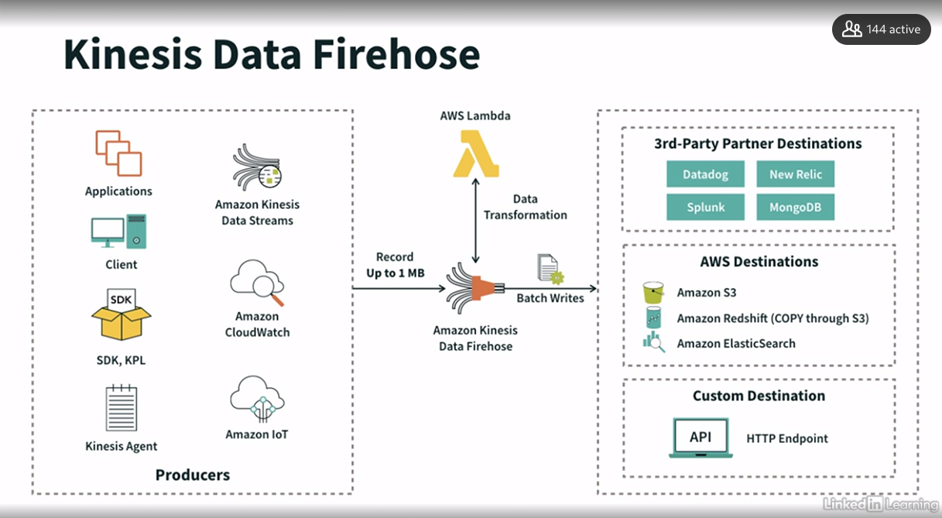

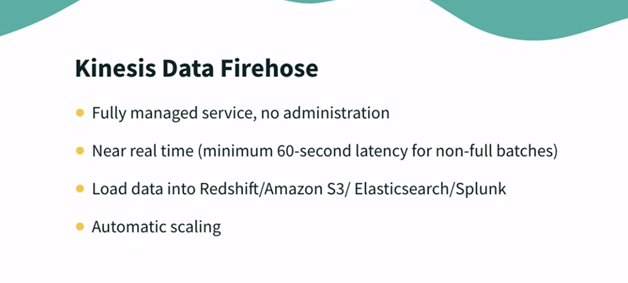

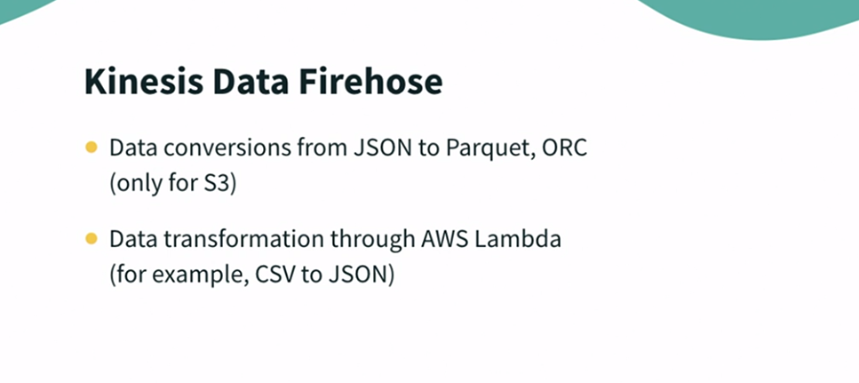

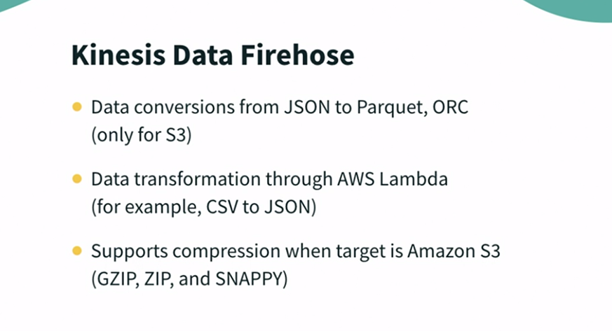

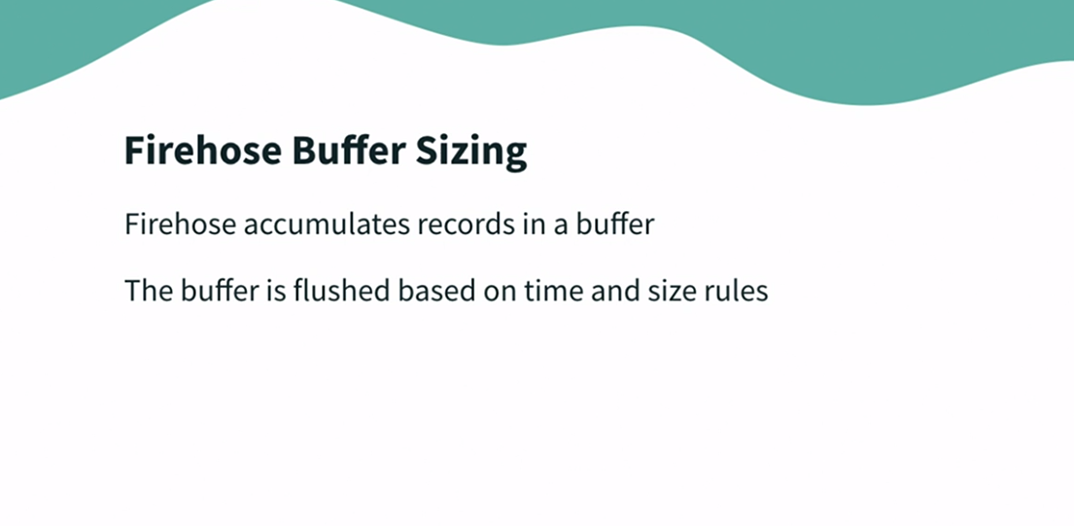

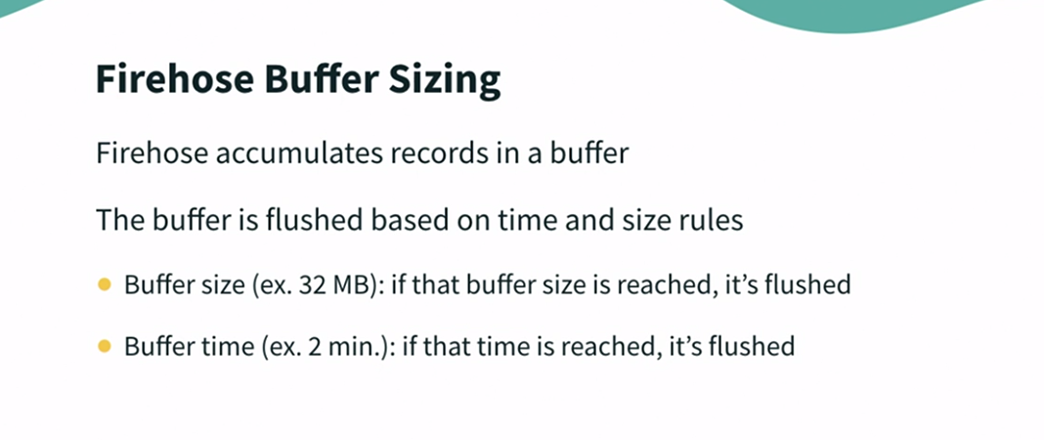

### **Demo Firehose**

Selecting transcript lines in this section will navigate to timestamp in the video

- [Instructor] Now, let's have a look how Kinesis' stream works. So let's get into Kinesis. As we discussed, we have different options available in Kinesis. For real time data processing, we use Kinesis Data Streams, while for near real time or when we want to batch the incoming data, we use Kinesis Firehose. So let's create our delivery stream here. So in this use case, what we are trying to do that we will be having incoming data in data stream. We will batch that data and write them into files in S3. So here, we can choose another Kinesis data stream as a source or we can also opt to write directly onto the data stream. So let's go ahead with this direct PUT option. And for destination, we will choose Amazon S3 while we have these many options available as a destination. Now we need to define some stream name. Let me call it Data Engineering Kinesis Demo. Now we also have flexibility to transform this incoming streaming data before we write into the files or before we write into any other destination and how we can introduce this transformation using Lambda functions. And we can also convert the format of incoming records. Let's say incoming data is coming in JSON format but while writing into S3, you want to convert it to Parquet or ORC. So you can simply enable this format conversion here. Now let's configure our bucket settings. Since we don't have any existing bucket, let's quickly create a new one. As we know, we need a unique name for bucket. Let's try if this Data Engineering Kinesis Demo is available. So let's create this bucket with all default settings. Yeah, we got this name. So this has created this bucket here, Data Engineering Kinesis Demo. Now let's go back to Firehose and select this bucket. Let's refresh it once. Here, we can choose this bucket. Now we can also provide, like any prefixes or partitioning detail if we want on our bucket but that is optional. Now this buffer setting is really important here. This buffer size, this can vary from one MIB to 128 MIB, while minimum buffer interval can be 60 second and maximum can be 900 seconds. What this means that there will be at least 60 second or one minute delay when we send data via Firehose. And that's the reason it is called near real time service. Now let's say we want to create five megabyte file in 60 seconds interval, whatever happens first. We can also define any compression or encryption. We can also define some additional settings for server side encryptions or if we want specific permissions. Now with these settings, let's simply create delivery stream. Normally, this stream creation takes few minutes. So now let's wait till the time it is available. Now this stream is created and we can see the status is active. And as we picked direct PUT as a source for this stream, means we need to explicitly write some data onto this. So let's test this stream with some test demo data. So here, this is the format that this is how data will be written onto the stream. Let's start sending this demo data means now it must have start sending data to our stream. Since we have configured five MB size and 60 minute interval, so whatever reaches to its threshold, it will start writing files on S3 bucket. So let's wait for some time. Let's stream, keep on pushing data, and then we will verify this data in our S3 bucket. So here, I'm into the S3 console and let's open our bucket which was Data Engineering Kinesis Demo. As of now, we don't see any folders here. But after one minute, we should see some files here. Now after some time, we have observed that it has created some folders here. So it has created, it has partitioned the incoming data into year, month, and then date and then it is hour. So let's try to see this file. So it has downloaded this file in here. Let me simply open it via Text Editor. So it has written some data into this file. So here we can see, it is some like ticker symbols data. So multiple records have been written. So starting from this bracket until this bracket, this is one record. So this is how it has written some records to this file. So it has read records from the incoming stream, batched those records and saved them into a file. So this is how you can use Kinesis Firehose. And we can also monitor some stats around this. So here, if I go into the monitoring, we can see that it has pumped some data into this and we can also see what is the like, incoming records per second. So we can also check these stats in the monitoring dashboard which is directly linked with CloudWatch. So Kinesis Data Firehose is very useful service when we work on the data intensive use cases, so we can batch this data for further analytics.

### **Data storage overview and design considerations**

Selecting transcript lines in this section will navigate to timestamp in the video

- [Instructor] Now moving on to the next stage in our data pipeline, which is data storage. Data storage is critical because that is where you are storing all of your data, so you need to think of very optimum solution for storage. If you look at Amazon use cases, S3 is the most used storage due to its cost effectiveness, security, durability, and rich features offering. Now, for all the things we should consider while designing a storage solution, first of all, we need to think about the access patterns, because depending on that, you will choose what kind of storage you want. Do you want to run complex SQLs or do you just want to provision data sets to a third party, or let's say just give access on this data to data scientist? So you need to understand the access pattern. And then there is a requirement of caching or not, because I may store all of my data in S3, but I may have data which is frequently used. So do I need caching? That need to be thought through. And then do I need versioning on my data? Is this data very, very critical? Do you need high availability or do we need to replicate this data into other regions? Also, you need to think what kind of data you are storing. Does it has to maintain relationship or linkages? Then I may need to opt a graph database like Neptune, or if it is a key value kind of data, then we will go for DynamoDB. If I want to use very, very heavy joins, then I would want to store my data in Redshift. So those are the design decisions we need to make as requirements, and the most important aspect that you need to look for cost that you are going to anchor when you implement this solution.

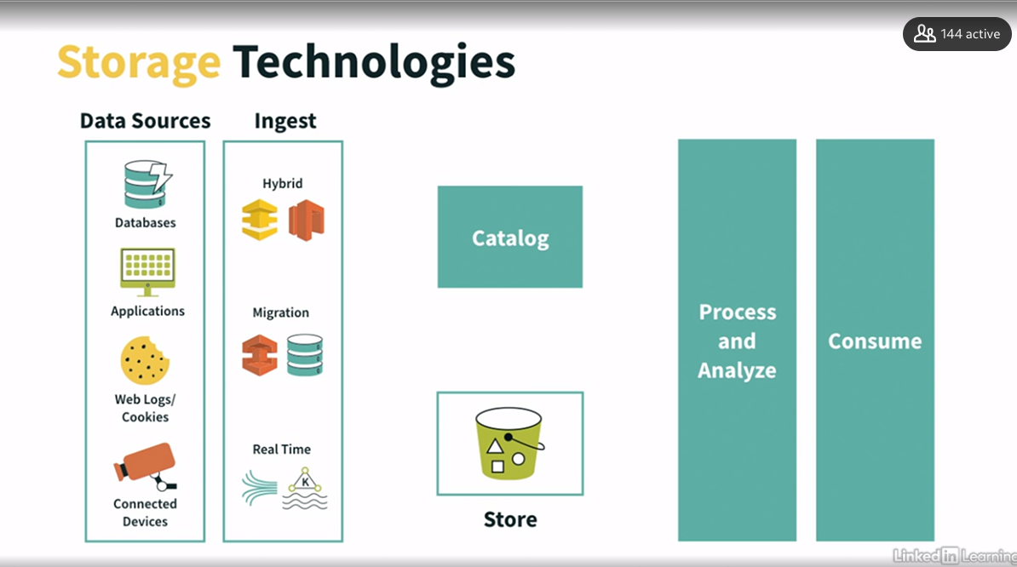

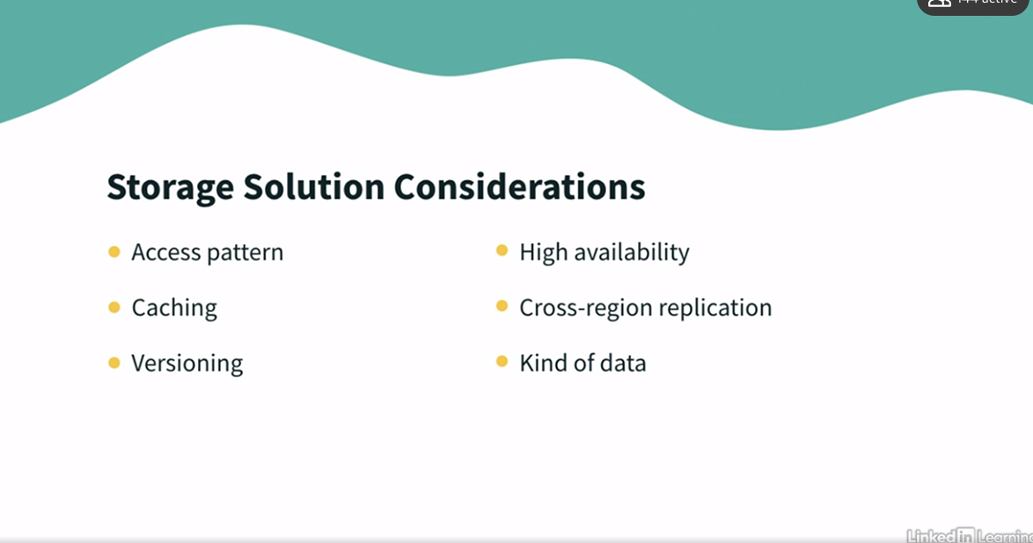

### **Storage technology landscape**

Selecting transcript lines in this section will navigate to timestamp in the video

- [Instructor] Now when we understand that different use cases may need different storage options. So AWS also provide different storage services to cater different needs. So let's look at them one by one. EBS is essentially a block storage, means your hard drive. This provide a persistent storage with your EC2 instances. They are low latency and all your web servers, database servers, analytics engines, all use EBS. EFS is high-performance network file system, which means it is used when we have 10, 20 or hundreds of computer that need to access the same data over network. It is elastic, so it grows with demand. And now third kind of storages, object store. Object storage is a technology that manage data as objects. All data is stored in one large repository, which may be distributed across multiple physical storage instead of being divided into files or folders. It allows retention of massive amounts of unstructured data. It is preferred storage for data lakes. In Amazon S3 is the object storage service.

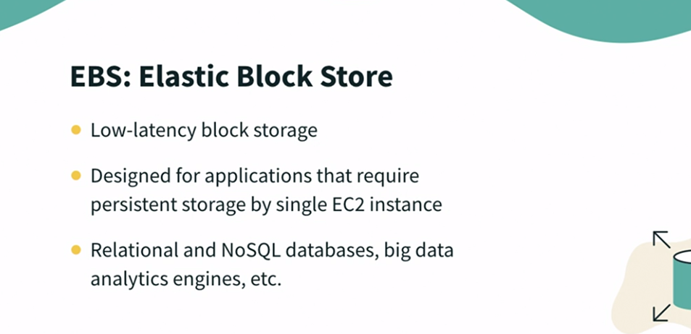

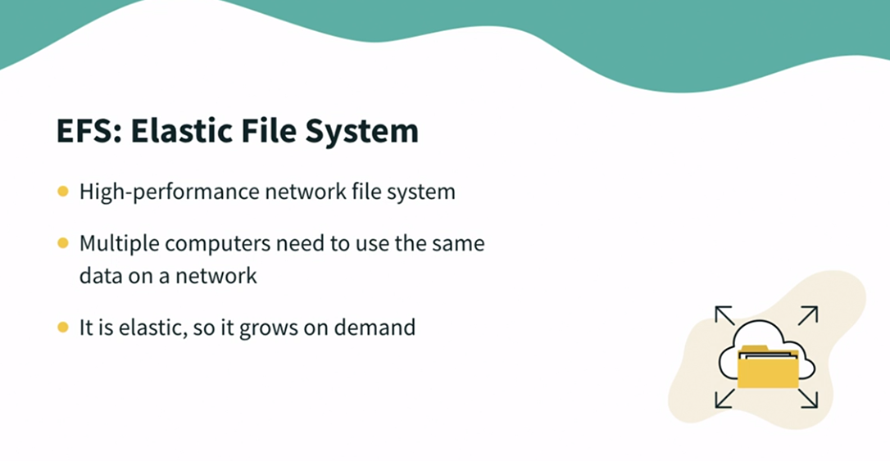

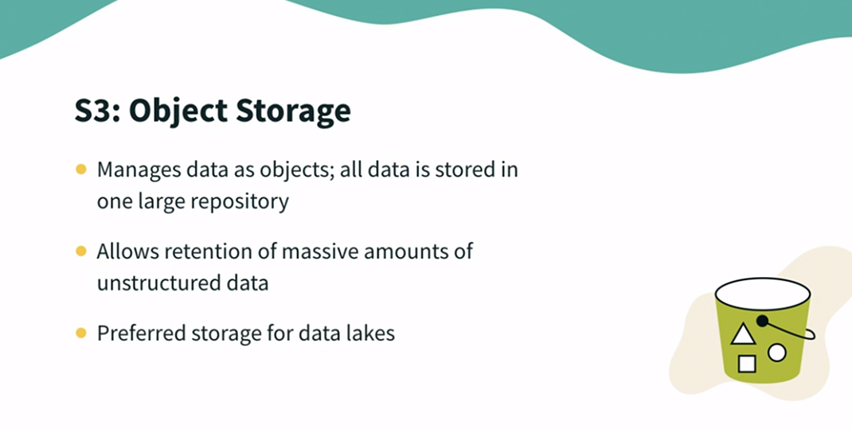

### **Elastic cache overview**

Selecting transcript lines in this section will navigate to timestamp in the video

- [Lecturer] In a web driven world, catering users request in real time is the goal of every web application. Because performance and speed are required, a caching layer, like Amazon ElastiCache, it is a first tool that every website employs in serving mostly static and frequently access data. So what benefits does a caching layer provide a user? Caching is a technique to store frequently accessed information, HTML pages, images and other static information in a temporary memory location on the server. Read-intensive web application are the best use-case for a cache service. There are a number of caching servers used across applications and most common caching technologies are Redis and Memcached. For real time processing, application need low latency and high throughput. Redis has emerged as a popular choice to store fast moving data and power real time applications. Developers love the performance, simplicity, and in-memory capabilities of Redis making it most popular key-value store. Redis blazing fast speed has made a de facto choice for caching use cases. Al**ong with rich support for in-memory data structures, Redis is also enables leaderboards, session stores, real time analytics, chat messaging and streaming use cases. Memcached is a popular open source in-memory data store that developer use as a high performance cache to speed up applications by storing everything in-memory rather than disk. Memcached can retrieve data in less than a millisecond. Memcached is a key-value store. This key uniquely identifies each record and lets Memcached quickly find it. Memcached is designed for simplicity while Redis offers a rich set of features that make it effective for a wide range of use cases. However, deploying, maintaining, scaling and monitoring, Redis and Memcached can be challenging.** Hence, Amazon came up with ElastiCache for Redis and Memcached as a fully managed service. That simplifies the administrative task, so you can focus on high value application development. It is compatible with Redis or Memcached, so your existing Redis or Memcached applications work seamlessly without changes.

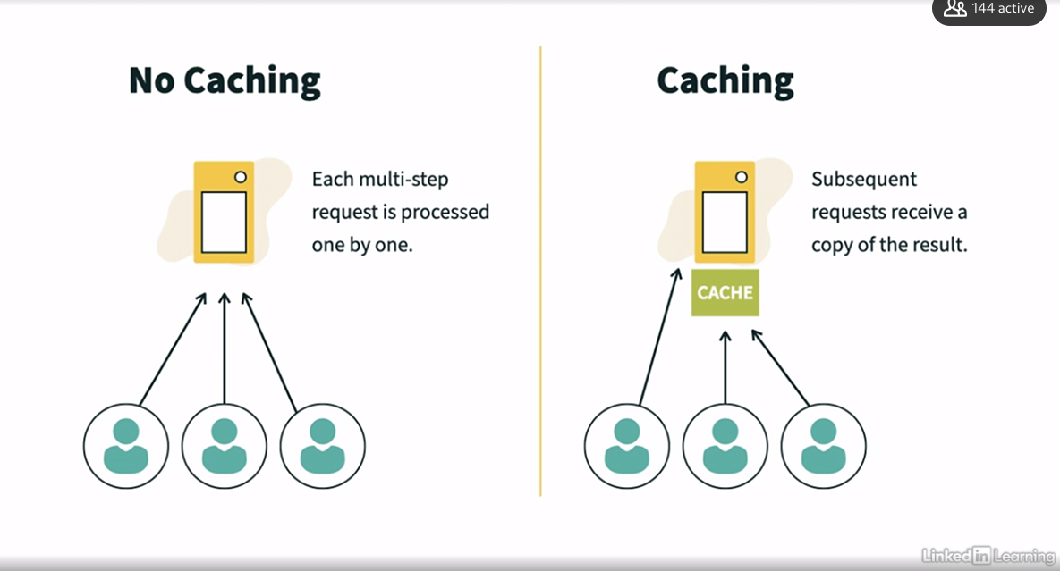

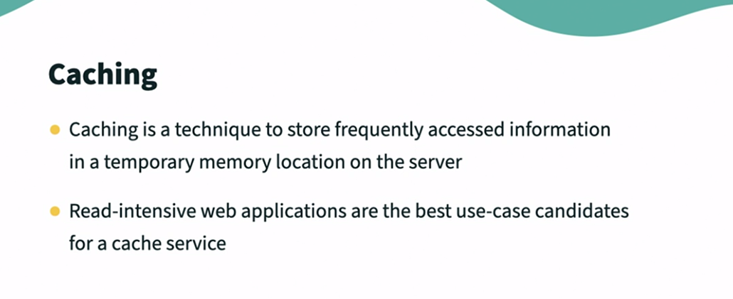

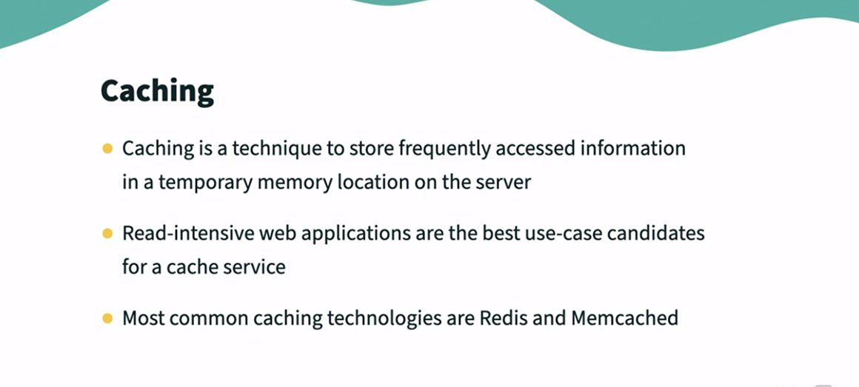



### **Amazon S3 overview**

Selecting transcript lines in this section will navigate to timestamp in the video

- [Instructor] Amazon S3 is one of the most heavily used storage service that is provided by AWS, simply down to the fact that it can be a great fit for many different use cases as well as integrating with many different AWS services. **Amazon S3 is a fully managed object-based storage that is highly available, highly durable, very cost effective, and widely accessible. The service itself is promoted as having unlimited storage capabilities, making S3 extremely scalable, far more scalable than our on-premise storage solutions could ever be. There are, however, limitations on the individual size of a single file that it can support. The smallest file size that it support is zero bytes and the largest file size is five terabytes.** T**he service operates as an object storage service, which means each object uploaded does not confirm to a data structure hierarchy like a file system. Instead, it's architectural accessed across a flat address space and is referenced by a unique URL. S3 is a regional service, and so while uploading data, we as a customer are required to specify the regional location for that data to be placed in. By specifying your region for your data, S3 will replicate your uploaded data multiple times across multiple availability zones within that region to increase both its durability and availability. Objects stored in S3 have a durability of 99.9 times 9 percent, known as 11 nines of durability. And so the likelihood of losing data is extremely rare.** And this is down to the fact that that S3 stores multiple copies of the same data in different AZs. The availability of S3 data, which refers to the uptime of S3 data, is dependent on the storage class, and this can range from 99.5 to 99.99%. Now let's create a bucket and store some objects in there. So here I am on AWS management console. Let's go to S3. In S3 we create buckets. You can think of bucket as a container for your data. Now, this is a list of buckets available in my account, and over here we have region in that bucket exist and the kind of formation this bucket has with the date created. Now, to create a new bucket, click on create bucket. let's name it data engineering S3 demo. And we are creating this bucket in US East one region. Now, this name must be completely unique, not just in your account, not just in the region you specify, but globally against all the other S3 buckets that exist. And this is because of the flat address space. You simply can't have a duplicate name. By default, public access, bucket versioning, and encryption are disabled. Let's create a bucket. So after we have created our bucket, which is here, now let's upload some file. Let's upload this sampledata.csv to our bucket. Any object uploaded to your bucket are given a unique object key to identify this. So here you can, if you select your file, you can see various detail related to this particular file. You can also open this file and check its content. Here we can see various detail that when this file was last modified and the storage class it belong to.

### **Amazon S3 storage classes and lifecycle rules**

Selecting transcript lines in this section will navigate to timestamp in the video

- [Narrator] As we understand that, customers have to manage large data sets. Single data set may have objects of different requirements. Storing them in wrong storage class can be costly. To help this, S3 offers wide range of storage classes, purpose-build for specific use cases and access patterns. This means you can store less frequently access data at cheaper rates, and even archive objects at the lowest cost for maximum saving. S3 storage classes are designed for scalability, availability, and industry-needing durability. Let's review all of the storage classes. Every S3 storage class supports specific data access level at corresponding cost or geographic location. For frequently access data with predictable access patterns, you can store mission critical production data in S3 Standard or Frequent Access. For data with changing, unknown, or unpredictable access patterns, such as data lakes, analytics, or new applications, use S3 Intelligent Tiering, which automatically optimize your storage cost. It moves your data between three low latency access tiers optimized for frequent, infrequent, and rare access. You can save cost by saving infrequently access data in S3 Standard-IA or S3 One Zone-IA. When objects become archived over time, you can activate archive access tier designed for a synchronous access and archive data at the lowest cost in archival storage classes, like S3 Glacier and S3 Glacier Deep Archive. You can use S3 storage class analysis to monitor access patterns across objects to discover data that you should be moved to lower cost storage classes. Then you can use this information to configure an S3 Life Cycle Policy that makes the data transfer. S3 Life Cycle Policies can also be used to expire objects at the end of their life cycle.

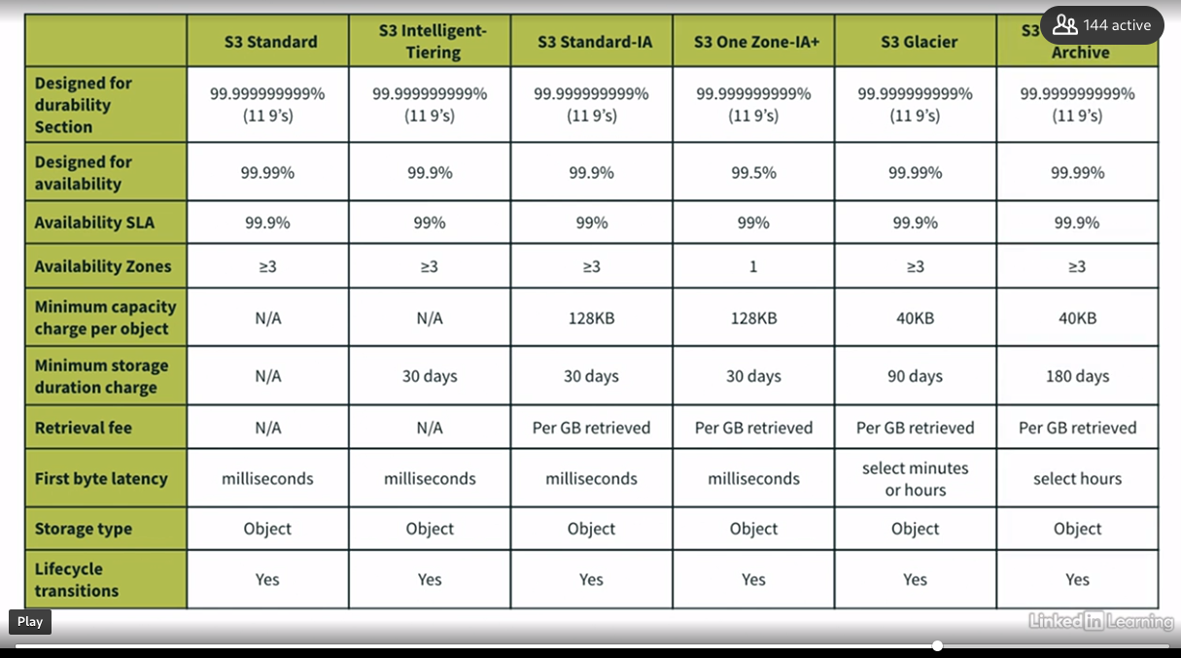

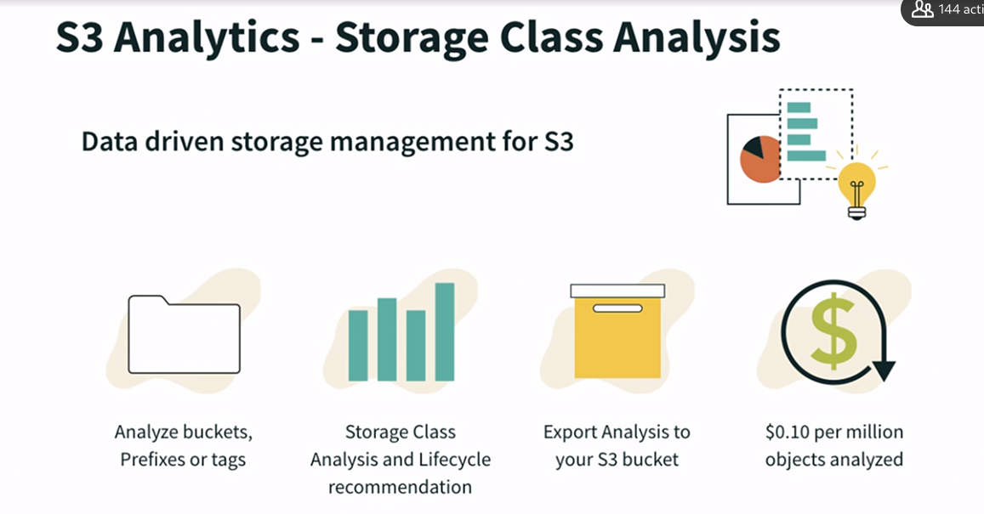

### **Amazon S3 Versioning and encryption**

Selecting transcript lines in this section will navigate to timestamp in the video

- [Instructor] We can store multiple versions of same file in our S3 bucket, but for that, we need to enable versioning in advance. **Let's see how to do that. So here, I'm on my S3 dashboard, and in my bucket, data engineering S3 demo. So if you go to Properties, here you see we have a property for bucket versioning. By default, it is disabled. Let's edit this and enable. Save changes. And now, try to upload same file, sampledata.csv one more time. So this file is uploaded. We can see only one version of sampledata.csv. However, we expect two. For that, we need to switch on versioning here. So as you see here, that first version has got the version ID as null because that time, versioning was not enabled. But after we enabled versioning and uploaded a file, it has got some version ID.** Now, let's try to upload same file one more time and see what happens. Again, if we see versions, then we can see we have got three versions of the same file. However, if we turn off versions, we can see there is only one file, sampledata.csv. Now, what will happen if we delete this file? Let's try to do that. So I'm seeing this sampledata.csv here, and trying to delete this one. So this time, it is asking me to write delete so I'm not deleting it mistakenly. So we have deleted this file. Now we don't see any of the file here, however, we are aware that we have uploaded multiple versions of the same file, so we should see that. Let's turn on the versioning again. So here if you notice, the file we deleted, it has got the Delete marker, while all other versions are intacted. We had three versions of this file, and we have all the three versions present here, and we can restore any of the desired version. However, as per the delete operation we just did, it simply placed a Delete marker. So it is a soft delete. It has not deleted the file physically from S3 bucket. Now if you want to permanently delete any file, you need to actually delete this versioned object rather than normal object. So let's say I want to delete this particular file, or let's try to delete a versioned file. So this time, it will ask me to write permanently delete because after we do this action, we won't be able to retrieve this file. And here in the versions, you can notice now that version is not available anymore. So versioning is a key feature to handle data for your production application. Now, let's quickly look at another key feature of S3, which is encryption. By default, encryption is disabled on your bucket. But we have option to enable this encryption. So why we encrypt our data? To safeguard our data, to keep our data secure. So I can enable encryption at the bucket level, or I can also enable encryption at the object level. For example, I don't want to encrypt all the files in my bucket, but I want only the files with a specific extension. Let's say only CSV file should be encrypted. So I can enable that encryption at the file level also. Let's see that in action. So let's try to upload another file here, which is logs.txt. And before you hit on Upload, go to Properties and add the properties for encryption. By default, encryption is disabled. However, you can enable it either using keys which are managed by S3 or using keys which are managed by KMS service. So let's encrypt our file using S3 manage keys. So if you try to see the details for this file, you will be able to see that encryption is enabled on this file and it is enabled using S3 managed keys encryption method. Now, let's try to see the similar details for previous files. Let's say we are trying to check encryption detail on this. We should be able to notice that encryption was disabled for this particular file. So that's how you can enable encryption on your individual files or at the bucket level so it is applied to all the files. So this is a very good way to secure your production applications data.

### **Amazon S3 security and event notifications**

Selecting transcript lines in this section will navigate to timestamp in the video

- [Instructor] Okay, so now let's talk about S3 security as this is the place which holds most of your data and need to be at most secure. There are multiple options to secure your S3 data. First you have user-based policy. So our IAM users have IAM policies and they authorize which API calls should be allowed, and if our user is authorized through IAM to access S3 then it's going to be able to do that. Then we have resource-based policies. They are bucket-wide policies that we can set in our S3 console. And what they do is that they will say what principles can and cannot do on our S3 bucket. And this enables us to do cross-account access to our S3 buckets. Then we have object ACLs, which is fine grain where we can define object-level access rule and finally we have bucket ACL. Okay, so S3 bucket policies are JSON-based policies. So JSON is a notation language. And so we have here our JSON bucket policy and this bucket policy here allows public read on our S3 buckets. So as we can see it says Effect: Allow, Principal: *, so anyone, the Action: GetObject on the resource samplebucket/*, means any objects within this bucket. So this is great. This allows public access to our S3 bucket. So these bucket policies can be applied to your buckets and objects both. The actions is allow a set of API to allow or deny. Now let's create our own policy to force objects to prevent putting objects that are not encrypted. And we will specifically check for SSE S3 encryption with AES-256. All right. To do that, let's go to our AWS management console. Here, I'm in my bucket data engineering S3 demo. So let's go to permissions and add this bucket policy. Here we have two links. Let's go to policy generator and create our policy. So we need to create this policy for our S3 bucket and this time, effect we want deny because when we are trying to upload the objects and if they are not encrypted, it should be denied. So we will choose this deny rule here. Principal should be * and what action we want this action on, when we are putting objects, mean put object is the API call here. Here it is. And here we need to provide bucket ARN which we can get from right here and /*. So it should be applicable to each file in this bucket. So we need to add conditions here because here we want to implicitly say that if my objects are not encrypted with SSE S3 encryption key, then it should not be allowed. So what we will say here in this condition, we will say that if it is Null, means if there is no encryption header, key in this case is going to be our encryption header which is s3-x-amz-server-side-encryption and value, let's say true. So what we are saying here that if this encryption header is Null, then deny. All right, so let's add this condition. And here we also want to specifically say that if this value is not equal to AES-256, then also it should deny. So we want to say if this string is not equal to AES-256, then also this effect should be deny. So let's add this statement and generate this policy. Copy this policy in your bucket policy area and save this. So, okay, here we have created our bucket policy. Now let's go to object and try to upload some file into this. So here we are trying to add a file. Let's say this logs.txt, and if I simply say Upload, ideally it should not allow me. So yes, it is failed. Let's see what is the reason. It says access denied, which is good. Now let's try to upload the same file after encryption. So this time we'll go to Properties and in the encryption setting, we will specify an encryption key. And what encryption key we want to specify? AES-256, which is this S3 manage key. So let's go ahead with this one. So this time our upload is succeeded. So this is how you can apply your custom policies on your S3 bucket. Now let's look at how to configure your buckets to monitor specific events that may occur within them. Any events which are recorded can then be sent to either SNS topic or SQS or to a Lambda function. Depending on this configuration of your destination for event notifications, permissions will need to be granted to your SNS topic or SQS or Lambda function to enable S3 to publish events to them. Let's see it in action by configuring our bucket for such event notifications. So the use case which we are trying here that whenever a new file is created in this bucket, it should notify us via an email. For that, we will use Simple Notification Service. Let's create a a standard topic and let's name it s3putevent, rest everything, you can keep default. After you created this topic, you need to create subscription so it can send email to a specific email ID. So here I'm defining my email ID. When you create this subscription, you can see it is showing status as pending confirmation, means we will need to go to our email ID and confirm this subscription. After this, this status is changed to confirmed. So now your topic is all set to send email to this particular email ID. As a next step, we need to fix the access policy for this topic so it can get events from S3. So let's edit this policy. So by default we have this default policy here and we are going to provide our custom policy which says that allow SNS publish to this particular topic which is s3putevent. Save these changes. So in your SNS, you have allowed your S3 to events to this topic, and then this topic is sending these events to your email ID. Now we need to go to S3 bucket and configure of a bucket for event notification. So let's go to properties and in event notifications section, create event notifications. You can name it anything, mys3events. And what is the event type that we want to trigger this event whenever a new object is being created. So we will select put event and our destination is going to be SNS topic. Choose the SNS topic which we have just created. So it says it has successfully created event notification. To test this, let's go to object and try to upload some file into this bucket. So let's upload the same logs.txt. And if you recall, this bucket has custom policy implemented where we say that it should accept only encrypted files with AES-256 header. So let's encrypt this file while uploading, I'm choosing this server-side encryption and upload this file. So it says upload succeeded. So ideally, we should have get one email about this upload. So let's check our inbox. So yes, we can see. So we have got this email notification here for put event in our bucket. So that's how you can create events for your buckets and also how you can push those notifications out to an SNS topic. So this is a very useful feature when you create your serverless pipelines or serverless workloads.

### **Challenge: Amazon S3**

Selecting transcript lines in this section will navigate to timestamp in the video

(upbeat music) - [Instructor] Here is a S3 challenge for you to host a aesthetic website on your bucket. For this you will need to create a bucket. While creating this bucket disable block public access and then add your website script, that is index.html in your bucket. Then create a bucket policy for public read access because you are trying to host a website means you will be accessing it from browsers. So you should allow public read access on this bucket. Then go to properties and enable aesthetic website hosting feature and then you are good to launch with the URL provided. Give it a try.

### **Solution: Amazon S3**

Selecting transcript lines in this section will navigate to timestamp in the video

(energetic music) - You can refer this video in case you stuck to complete the challenge. So here I am on S3 dashboard. Let's create a bucket. I'm naming it as data engineering S3 hosting. And I'm disabling this setting, block public access, and acknowledging that, Yes, I am turning off this setting. And hit create bucket. So my bucket is created. So now I need to add my index.html file into this bucket. So this file is available in Get Up. So we have simply uploaded this file in here. As a next step, we need to go to permissions because we need to give public access on this bucket. Okay, so we need to write a bucket policy. Let's add this. Let's go to policy generator. So we want to write policy for S3, allow to everyone. And then action, we just want to give like read access, which is GetObject. Let's select this one. And here we need to provide our bucket (ARN) which we can get from right here. And then slash star. So we are able to read each and every file within this bucket. Let's add this statement in generate policy. Try to save this. So we have successfully added this policy and now if you notice, it has given this publicly accessible tag on of a bucket. So it's all fine. Next, we need to go to properties and enable website hosting on this bucket. So here we need to provide our index document name which is index.html in lower case. Rest everything you can leave default and save changes. The moment you do this, it gives you a URL. Try to launch this URL and here you go. You are able to see your webpage which you have added as a index.html. I hope you find it interesting.

### **Next steps**

Selecting transcript lines in this section will navigate to timestamp in the video

- [Dipali] Congratulations on completing this course. You are already halfway through your data engineering journey. In this course, you understood what exactly data engineering is and what all is needed to be a data engineer. Here you learned how to deal with variety of data sources, data ingestions, and efficient storage mechanism for various use cases. While in part two, we will dive into the metadata cataloging, processing, analytics, and visualization of data in data pipeline. Stay tuned for this exciting journey ahead. Feel free to connect with me on LinkedIn, and follow my blog on Medium to learn more about emerging AWS concepts.